INDIRECT TAX

UNIT–I:
IntroductiontoTaxation:Indirecttaxes-Meaning-Features–ObjectivesofTaxation– Canons – Taxation under the Constitution - Direct Tax Vs Indirect Tax – AdvantagesandDisadvantagesofindirecttaxes-VarioustypesofIndirecttaxes.

UNIT–II:

Customs Duty: Types of Customs Duty – Abatement Duty in Damaged or Deteriorated Goods –Customs Tariff Act1995–CustomsDuty Drawback-Objectives–Levy and Collection–Classification of Goods––Valuation of Goods

UNIT–III:

Introduction to GST:GSTBackground–GenesisofGSTinIndia–Concept–Need
–TaxesSubsumedinGST–GoodsnotcoveredinGST-TaxesinGST(CGST,SGST,andIGST)–AdvantagesandDisadvantagesofGST–FrameworkofGSTinIndia

UNIT–IV:

Supply and Its Forms: Supply – Meaning – Forms – Concept of Supply (Section 7 of CGST) - Composite and Mixed Supplies (Section 8) – Place of Supply - Time of Supply of Goods (Section12)–Time of Supply of Services(Section–13)-Valuation of Supply

UNIT–V:

Incidence of Tax:Incidenceoftax–RatesofGSTinIndia–GoodsExemptfrom Tax
- Exemption and Exempt Supplies – Power of Grant Exemption from Tax (Section 11 of CGSTAct/ Section 6 of IGST Act) - Input Tax Credit (ITC) – Eligibility and Condition – KeyElementsofITC
CONTENTS
Chapter Pages

1. Introduction to Taxation 1 - 30
Indirect taxes-Meaning-Features–Objectives of Taxation– Canons – Taxation under the Constitution - Direct Tax Vs Indirect Tax – Advantages and Disadvantages of indirect taxes-Various types of Indirect taxes

2. Customs Duty 31 - 36
Types of Customs Duty – Abatement Duty in Damaged or Deteriorated Goods –Customs Tariff Act1995–CustomsDuty Drawback-Objectives–Levy and Collection–Classification of Goods––Valuation of Goods

3. GST 37 - 49
Introduction to GST: GST Back ground–Genesis of GS T in India–Concept–Need
–Taxes Subsumed in GST–Goods not covered in GST-Taxes in GST(CGST,SGST,andIGST)–Advantages and Disadvantages of GST–Framework of GST in India

4. Supply and Its Forms 50 - 57
Supply – Meaning – Forms – Concept of Supply (Section 7 of CGST) - Composite and Mixed Supplies (Section 8) – Place of Supply - Time of Supply of Goods (Section12)–Time of Supply of Services(Section–13)-Valuation of Supply

5. Incidence of Tax 58 - 71
Incidence of tax–Rates of GST in India–Goods Exempt from Tax-Exemption and Exempt Supplies – Power of Grant Exemption from Tax (Section 11 of CGST Act/ Section 6 of IGST Act) - Input Tax Credit (ITC) – Eligibility and Condition – KeyElements of ITC
Introduction toTaxation
Introduction to Taxation
Meaning of tax
A tax may be defined as a "pecuniary burden laid upon individuals or property owners to support the Government, a payment exacted by legislative authority”. A tax "is not a voluntary payment or donation, but an enforced contribution, exacted pursuant to legislative authority". In simple words, tax is nothing but money that people have to pay to the Government, which is used to provide public services.
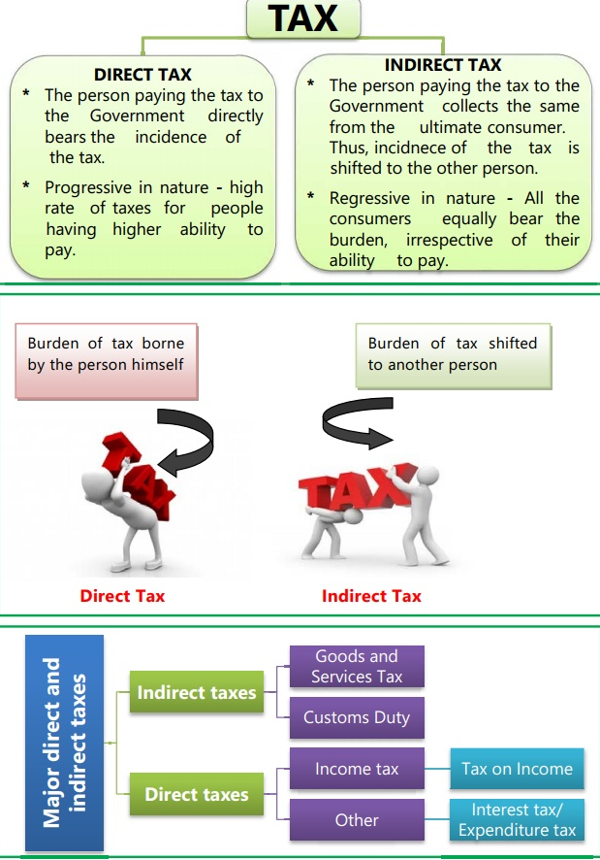
Kinds of taxes
1. Direct Tax
2. Indirect Tax.

Diagram 1.1

Introduction toTaxation

Direct Tax:
If a tax levied on the income or wealth of a person and is paid by that person (or his office) directly to the Government, it is called direct tax e.g. Income-Tax, Wealth Tax, Capital Gains Tax, Securities Transaction Tax, Fringe Benefits Tax (from 2005), Banking Cash Transaction Tax (for Rs.50,000 and above from 2005), etc. In India all direct taxes are levied and administered by Central Board of Direct Taxes.

Indirect Tax
An indirect tax is one in which the burden can be shifted to others. The tax payer is not the tax bearer. The impact and incidence of indirect taxes are on different persons. An indirect tax is levied on and collected from a person who manages to pass it on to some other person or persons on whom the real burden of tax falls. For e.g. commodity taxes or sales tax, excise duty, custom duties,GST etc. are indirect taxes.
The indirect taxes are the levies made by Central and State government on the expenditure, consumption, services, rights and privileges yet not on the property or income. This includes duties of customs paid on imports, as well as excise duty paid on production and value added tax on certain stages of production and distribution of products etc.
All these comprise to make indirect taxes since they are not directly applicable on the consumer’s income. Considering that indirect taxes are less as compared to income tax due to invisibility on pay slip, various state agencies tend to raise these taxes so as to generate higher revenue. Indirect tax is often also known as the consumption tax, since they are a regressive measure in application, and not rooted in paying ability.

Introduction toTaxation
Definition of Indirect Tax
According to Dalton,"In the case of a direct tax, the tax payer who pays a direct tax is also the tax bearer”. In the case of indirect taxes, the taxpayer and the tax bearer are different persons.

Features of Indirect Taxes
The features of indirect taxes that’ll help you understand them better:
- Indirect taxes are not levied on your annual income/profit but on goods and services you purchase
- While sellers of goods and services must pay indirect tax to the government, the burden is shifted to the customer. Thus, the tax is charged at the point of sale
- Indirect taxes tend to be regressive as the burden of taxation is a flat rate. However, the introduction of GST has helped change this in India
- Evading indirect taxes is impossible as they are included in the prices of various goods and services
- People with incomes crossing a certain threshold must pay direct taxes. However, indirect taxes have broader social coverage since they apply to all goods and services people purchase
- A high indirect tax means a higher price for the commodity or service. This generally incentivizes spending in consumers, motivating them to save and invest

Introduction toTaxation
Difference between Direct tax and Indirect tax

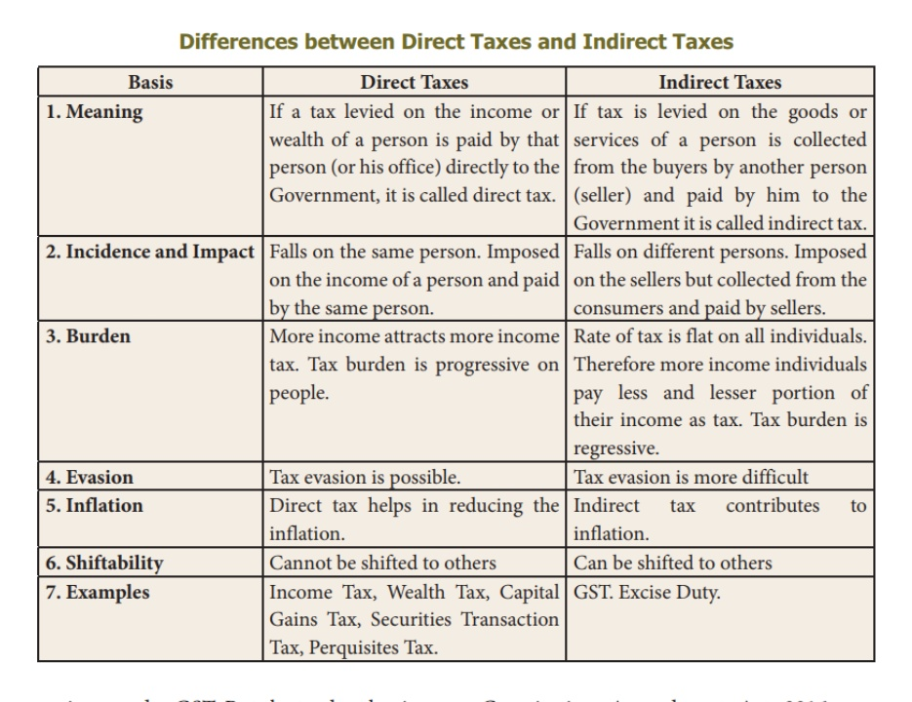
Introduction toTaxation
Types of Indirect Taxes:
Service Tax
Every paid service comes with a service tax. For instance, when you avail of various services like booking a hotel or cab services, you are liable to pay an indirect service tax on the value of the service.
Excise Duty
Also known as the Central Value Added Tax, Excise Duty applies to all goods produced within the country's borders. For instance, if your company manufactures laptops in India, you will have to pay excise duty. This tax amount is later recovered from customers
Customs Duty
This type of indirect tax is charged on goods imported into India. For instance, a customs duty will apply to gold or diamond jewellery you bring back from a foreign trip.
Value-Added Tax
VAT is the indirect tax levied on the value added at every stage of the supply chain. For instance, you purchase gold jewellery for ₹3 Lakhs. If the applicable VAT rate is 1%, the VAT payable on the amount will be ₹3,000.
Stamp Duty
Stamp Duty serves as legal proof of ownership. It is levied on the sale of immovable property in India. For instance, if you buy a property, the stamp duty must be paid in full per the state government’s taxation rates.
Entertainment Tax
Transactions related to entertainment are subject to entertainment taxes. For instance, if you purchase movie or concert tickets online, you will need to pay the entertainment tax according to the state government's applicable rates.
GST
In 2017, GST, or the Goods and Service Tax, was introduced in India to subsume 17 different indirect taxes at the central and state levels. Eliminating the cascading effect of indirect taxes, GST has absorbed the following major types of indirect taxes:
Introduction toTaxation
At the Central level:
- Sales tax
- Entertainment tax
- Purchase tax
- Octroi and Entry tax
- Luxury Tax
At the State level:
- Service tax
- Excise duty
- Additional custom duty
- Countervailing duty
So, for instance, you’re dining at a restaurant, and the total bill comes to Rs.3,000, and the GST applied is 5%. Then, the total payable will be Rs.3,150, where Rs.150 is the indirect tax.

Introduction toTaxation

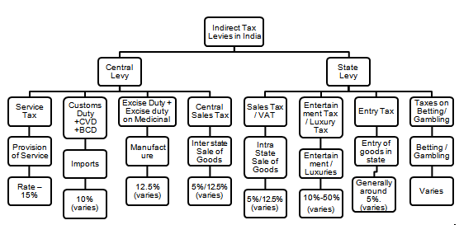
Introduction toTaxation
Taxation in India before GST
Liability of Tax
Here the seller or service provider makes payment on indirect taxes which are transferred to final consumer.
Investment and Saving
Most indirect taxes are largely growth-oriented since they de-motivate the consumer and encourage savings.
Social Coverage:
The indirect tax has a much larger coverage since their charge falls upon each individual buying products or services.
An important source of revenue:
Indirect taxes are a major source of tax revenues for Governments worldwide and continue to grow as more countries move to consumption oriented tax regimes. In India, indirect taxes contribute more than 50% of the total tax revenues of Central and State Governments.
Tax on commodities and services:
It is levied on commodities at the time of manufacture or purchase or sale or import/export thereof. Hence, it is also known as commodity taxation. It is also levied on provision of services.
Shifting of burden:
There is a clear shifting of tax burden in respect of indirect taxes. For example, GST paid by the supplier of the goods is recovered from the buyer by including the tax in the cost of the commodity.
No perception of direct pinch:
Since, value of indirect taxes is generally inbuilt in the price of the commodity, most of the time the tax payer pays the same without actually knowing that he is paying tax to the Government. Thus, tax payer does not perceive a direct pinch while paying indirect taxes.
Introduction toTaxation
Inflationary:
Tax imposed on commodities and services causes an all-round price spiral.In other words, indirect taxation directly affects the prices of commodities and services and leads to inflationary trend.
Wider tax base:
Unlike direct taxes, the indirect taxes have a wide tax base. Majority of the products or services are subject to indirect taxes with low thresholds.
Promotes social welfare:
High taxes are imposed on the consumption of harmful products (also known as ‘sin goods’) such as alcoholic products, tobacco products etc. This not only checks their consumption but also enables the State to collect substantial revenue.
Regressive in nature: Generally, the indirect taxes are regressive in nature. The rich and the poor have to pay the same rate of indirect taxes on certain commodities of mass consumption. This may further increase the income disparities between the rich and the poor.
Hicks classifies direct & indirect taxes on the basis of administrative arrangements. In case of direct tax-there is a direct relationship between the taxpayer and the revenue authorities. A tax collecting agency directly collects the tax from the taxpayers, whereas in case of indirect taxes there is no direct relationship between the taxpayers and the revenue authorities. They are collected through traders and manufacturers.
Over the years the share of indirect tax has declined in India due to reduction in the rates of indirect taxes.

Advantages / Merits of Indirect Taxes
The merits of indirect taxes are briefly explained as follows :-
1. Convenient
Indirect taxes are imposed on production, sale and movements of goods and services. These are imposed on manufacturers, sellers and traders, but their burden may be shifted to consumers of goods and services who are the final taxpayers. Such taxes, in the form of higher prices, are paid only on purchase of a commodity or the
Introduction toTaxation
enjoyment of a service. So taxpayers do not feel the burden of these taxes. Besides, money burden of indirect taxes is not completely felt since the tax amount is actually hidden in the price of the commodity bought. They are also convenient because generally they are paid in small amounts and at intervals and are not in one lump sum. They are convenient from the point of view of the government also, since the tax amount is collected generally as a lump sum from manufacturers or traders.
2. Difficult to evade
Indirect taxes have in built safeguards against tax evasion. The indirect taxes are paid by customers, and the sellers have to collect it and remit it to the Government. In the case of many products, the selling price is inclusive of indirect taxes. Therefore, the customer has no option to evade the indirect taxes.
3. Wide Coverage
Unlike direct taxes, the indirect taxes have a wide coverage. Majority of the products or services are subject to indirect taxes. The consumers or users of such products and services have to pay them.
4. Elastic
Some of the indirect taxes are elastic in nature. When government feels it necessary to increase its revenues, it increases these taxes. In times of prosperity indirect taxes produce huge revenues to the government.
5. Universality
Indirect taxes are paid by all classes of people and so they are broad based. Poor people may be out of the net of the income tax, but they pay indirect taxes while buying goods.
6. Influence on Pattern of Production
By imposing taxes on certain commodities or sectors, the government can achieve better allocation of resources. For e.g. By Imposing taxes on luxury goods and making them more expensive, government can divert resources from these sectors to sector producing necessary goods.
7. May not affect motivation to work and save
The indirect taxes may not affect the motivation to work and to save. Since, most of the indirect taxes are not progressive in nature, individuals may not mind to pay them. In other words, indirect taxes are generally
Introduction toTaxation
regressive in nature. Therefore, individuals would not be demotivated to work and to save, which may increase investment.
8. Social Welfare
The indirect taxes promote social welfare. The amount collected by way of taxes is utilized by the government for social welfare activities, including education, health and family welfare. Secondly, very high taxes are imposed on the consumption of harmful products such as alcoholic products, tobacco products, and such other products. So it is not only to check their consumption but also enables the state to collect substantial revenue in this manner.
9. Flexibility and Buoyancy
The indirect taxes are more flexible and buoyant. Flexibility is the ability of the tax system to generate proportionately higher tax revenue with a change in tax base, and buoyancy is a wider concept, as it involves the ability of the tax system to generate proportionately higher tax revenue with a change in tax base, as well as tax rates.

Disadvantages / Demerits of Indirect Taxes
Although indirect taxes have become quite popular in both developed & Under developed countries alike, they suffer from various demerits, of which the following are important.
1. High Cost of Collection
Indirect tax fails to satisfy the principle of economy. The government has to set up elaborate machinery to administer indirect taxes. Therefore, cost of tax collection per unit of revenue raised is generally higher in the case of most of the indirect taxes.
2. Increase income inequalities
Generally, the indirect taxes are regressive in nature. The rich and the poor have to pay the same rate of indirect taxes on certain commodities of mass consumption. This may further increase income disparities among the rich and the poor.
Introduction toTaxation
3. Affects Consumption
Indirect taxes affects consumption of certain products. For instance, a high rate of duty on certain products such as consumer durables may restrict the use of such products. Consumers belonging to the middle class group may delay their purchases, or they may not buy at all. The reduction in consumption affects the investment and production activities, which in turn hampers economic growth.
4. Lack of Social Consciousness
Indirect taxes do not create any social consciousness as the taxpayers do not feel theburden of the taxes they pay.
5. Uncertainty
Indirect taxes are often rather uncertain. Taxes on commodities with elastic demand are particularly uncertain, since quantity demanded will greatly affect as prices go up due to the imposition of tax. In fact a higher rate of tax on a particular commodity may not bring in more revenue.

6. Inflationary
The indirect taxes are inflationary in nature. The tax charged on goods and services increase their prices. Therefore, to reduce inflationary pressure, the government may reduce the tax rates, especially, on essential items.
7. Possibility of tax evasion
There is a possibility of evasion of indirect taxes as some customers may not pay indirect taxes with the support of sellers. For instance, individuals may purchase items without a bill, and therefore, may not pay Sales tax or VAT (Value Added Tax), or may obtain the services without a bill, and therefore, may evade the service tax.
Taxation in India.(Constitutional provisions)
India has a three-tier federal structure, comprising the Union Government, the State Governments and the Local Government. The power to levy taxes and duties is distributed among the three tiers of Governments, in accordance with the provisions of the Indian Constitution.
Introduction toTaxation
The Constitution of India is the supreme law of India. It consists of a Preamble, 25 parts containing 448 Articles and 12 Schedules.
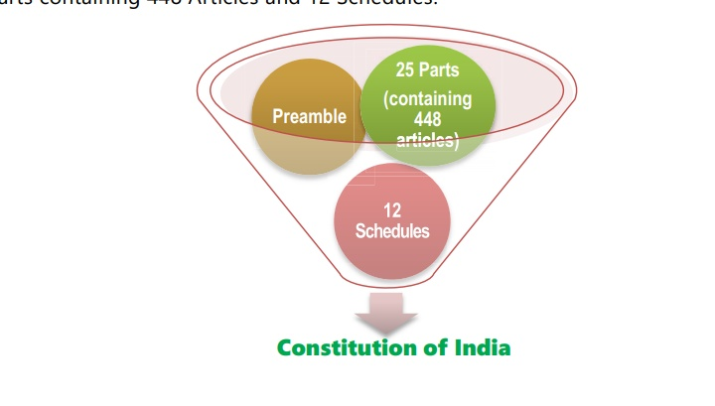

Diagram 1.3
Thus, a study of the basic provisions of the Constitution is essential for understanding the genesis of the various taxes being imposed in India. The significant provisions of the Constitution relating to taxation are:
I. Article 265: Article 265 of the Constitution of India prohibits arbitrary collection of tax. It states that “no tax shall be levied or collected except by authority of law”. The term “authority of law” means that tax proposed to be levied must be within the legislative competence of the Legislature imposing the tax.
II. Article 245: Part XI of the Constitution deals with relationship between the Union and States. The power for enacting the laws is conferred on the Parliament and on the Legislature of a State by Article 245 of the Constitution. The said Article provides as under
- Subject to the provisions of this Constitution, Parliament may make laws for the whole or any part of the territory of India, and the legislature of a State may make laws for the whole or any part of the State.
- No law made by the Parliament shall be deemed to be invalid on the ground that it would have extra-territorial operation.
III. Article 246: It gives the respective authority to Union and State Governments for levying tax. Whereas Parliament may make laws for the whole of India or any part of the territory of India, the State Legislature may make laws for whole or part of the State
Introduction toTaxation
IV. Seventh Schedule to Article 246: It contains three lists which enumerate the matters under which the Union and the State Governments have the authority to make laws.
List I-----UNION LIST It contains the matters in respect of which the Parliament(Central Government)has the exclusive right to make laws.
LIST – II -----STATE LIST It contains the matters in respect of which the State Government has the exclusive right to make laws.
List-III----- CONCURRENT LIST It contains the matters in respect of which both the Central l& State Governments have power to make law.
Entries 82 to 91 of List I enumerate the subjects where the Central Government has power to levy taxes. Entries 45 to 63 of List II enumerate the subjects where the State Governments have the power to levy taxes. Parliament has a further power to make any law for any part of India not comprised in a State even if such matter is included in the State List.

Income tax is levied by virtue of Entry 82 - Taxes on income other than agricultural income and customs duty vide Entry 83 - Duties of customs including export duties of the Union List. Power to levy Goods and Services Tax (GST) has been conferred by Article 246A of the Constitution which was introduced by the Constitution (101st Amendment) Act, 2016. Before discussing the significant provisions of the Constitution (101st Amendment) Act, 2016, let us first understand why there arose a need for such constitutional amendment.
Need for constitutional amendment
The Constitutional provisions hitherto had delineated separate powers for the Centre and the States to impose various taxes. Whereas the Centre levied excise duty on all goods produced or manufactured in India, the States levied Value Added Tax once the goods entered the stream of trade upon completion of manufacture. In the case of inter-State sales, the Centre had the power to levy a tax (the Central Sales Tax), but the tax was collected and retained entirely by the States. Services were exclusively taxed by the Centre together with applicable cesses, if any. Besides, there were State specific levies like entry tax, Octroi, luxury tax, entertainment tax, lottery and betting tax, local taxes levied by Panchayats etc. With respect to goods imported from outside the country into India, Centre levied basic customs duty and additional duties of customs together with applicable cesses, if any. Introduction of the GST required amendment in the Constitution so as to enable
Introduction toTaxation
integration of the central excise duty including additional duties of customs, State VAT and certain State specific taxes and service tax levied by the Centre into a comprehensive Goods and Services Tax and to empower both Centre and the States to levy and collect it. Consequently, Constitution (101st Amendment Act), 2016 (hereinafter referred to as Constitution Amendment Act) was passed. It has 20 sections. Newly inserted Article 279A empowering President to constitute GST Council was notified on 12.09.2016. Remaining provisions were notified with effect from 16.09.2016.
CAA also provides for compensation to States for loss of revenue on account of introduction of goods and services tax. Parliament shall, by law, on the recommendation of the Goods and Services Tax Council, provide for compensation to the States for loss of revenue arising on account of implementation of the goods and services tax for a period of five years.
Significant provisions of Constitution (101st Amendment) Act, 2016

Key changes in brief
- Concurrent powers on Parliament and State Legislatures to make laws governing taxes on goods and services.
- Levy of integrated goods and services tax on inter-State transactions of goods and services to be levied and collected by the Central Government and apportioned between the Union and the States in the manner provided by Parliament by Law as per the recommendation of the GST Council
- Principles for determining the place of supply and when a supply takes place in the course of inter-State trade or commerce shall be formulated by the Parliament, by law.
- GST will be levied on all supply of goods and services except alcoholic liquor for human consumption.
- On the following products GST shall not be levied, till a date to be notified on the recommendations of the GST Council:

Introduction toTaxation
Petroleum Crude
High Speed Diesel
Motor Spirit (commonly known as Petrol
Natural Gas
Aviation Turbine Fuel
The Union Government shall retain the power to levy duties of excise on the aforesaid products besides tobacco and tobacco products manufactured or produced in India.
Article 279A of the Constitution empowers the President to constitute a joint forum of the Centre and States namely, Goods & Services Tax Council(GST Council).
The provisions relating to GST Council came into force on 12th September, 2016. President constituted the GST Council on 15th September, 2016.

The Union Finance Minister is the Chairman of this Council and Ministers in charge of Finance/Taxation or any other Minister nominated by each of the States & UTs with Legislatures are its members. Besides, the Union Minister of State in charge of Revenue or Finance is also its member. The function of the Council is to make recommendations to the Union and the States on important issues like tax rates, exemptions, threshold limits, dispute resolution etc.
The concept of ‘declared goods of special importance’ under the Constitution is done away with. Presently, certain restrictions are placed on the powers of States in regard to tax on such goods.
Transitional provisions to take care of any inconsistency with respect to any law relating to tax on goods or services or both, in force in any State. Such tax to continue to be in force until amended or repealed or until expiration of one year from commencement of GST, whichever is earlier.
Key changes in detail
Significant amendments made by Constitution Amendment Act are discussed below in detail:
V. Article 246A: Power to make laws with respect to Goods and Services Tax:
Newly inserted Article 246A
(1) Notwithstanding anything contained in Articles 246 and 254, Parliament, and, subject to clause (2), the
Introduction toTaxation
Legislature of every State, have power to make laws with respect to goods and services tax imposed by the Union or by such State.
(2) Parliament has exclusive power to make laws with respect togoods and services tax where the supply of goods, or of services, or both takes place in the course of inter-State trade or commerce.
Explanation—The provisions of this article, shall, in respect of goods and services tax referred to in clause (5) of article 279A, take effect from the date recommended by the Goods and Services Tax Council. This article grants power to Centre and State Governments to make laws with respect to GST imposed by Centre or such State. Centre has the exclusive power to make laws with respect to GST in case of inter-State supply of goods and/or services .However, in respect to

the following goods, the aforesaid provisions shall apply from the date recommended by the GST Council:
- This article grants power to Centre and State Governments to make laws with respect to GST imposed by Centre or such State.
- Centre has the exclusive power to make laws with respect to GST in case of inter-State supply of goods and/or services.
- However, in respect to the following goods, the aforesaid provisions shall apply from the date recommended by the GST Council:
*petroleum crude
*high speed diesel
*motor spirit (commonly known as petrol)
*Natural gas
*aviation turbine fuel
- The provisions of Article 246A are notwithstanding anything contained in Articles 246 and 254. Article 254 deals with the supremacy of the laws made by Parliament.
VI. Article 248 amended Residuary powers of legislation amended

Introduction toTaxation
- Article 248 grants the residuary powers to Parliament to make laws with respect to any matter not enumerated in the Concurrent List or State List. Such power shall include the power of making any law imposing a tax not mentioned in either of those Lists.
- This article has been amended. Now, this power has been subjected to Article 246A, namely the power to make laws with respect to goods and service tax to be imposed by the Centre and States.
VII. Power of Parliament to legislate with respect to a matter in the State List, in the national interest/in case of emergency, extended to GST provided under Article 246A
- Article 249 grants the Parliament the power to make laws with respect to a matter in the State list in national interest in a case where the Council of States has declared by resolution supported by not less than two-thirds of the members present and voting on any matter enumerated in the State List.
- Similarly, Article 250 grants the Parliament the power to make laws with respect to any of the matters enumerated in the State List if a proclamation of Emergency is in operation.
- Articles 249 and 250 have been amended to grant power to Parliament to make laws with respect to the Goods and Services Tax provided under Article 246A also alongwith the matters in the State list, in the national interest/in case of emergency.
VIII.Article 268: Duties levied by the Centre but collected and appropriated by the States
- Article 268 pertains to the duties levied by the Centre but collected and appropriated by the States. It stipulates that such stamp duties and such duties of excise on medicinal and toilet preparations as are mentioned in the Union List shall be levied by the Government of India but shall be collected in the case where such duties are leviable within any Union territory, by the Government of India, and in other cases, by the States within which such duties are respectively leviable.
- The CAA omits “and such duties of excise on medicinal and toilet preparations” from Article 268.
- Duties of excise on medicinal and toilet preparations have been subsumed into the goods and service tax to be levied by the Centre and States.
IX. Article 268A: Article 268A empowering Union to levy service tax omitted
Introduction toTaxation
- Service tax was levied in 1994 under the residual Entry 97 of the Union list. Article 268A was inserted by the Constitution (88th)
Amendment Act, 2003 to usher in service tax
under a separate entry 92C in the Union List. However, it was not notified ever since. This article has been omitted by the CAA.
X. Article 269A: Levy and collection of GST on inter-State supply
Newly inserted article 269A. Levy and collection of goods and services tax in course of inter-State trade or commerce
(1) Goods and services tax on supplies in the course of inter-State trade or commerce shall be levied and collected by the Government of India and such tax shall be apportioned between the Union and the States in the manner as may be provided by Parliament by law on the recommendations of the Goods and Services Tax Council.
Explanation — For the purposes of this clause, supply of goods, or of services, or both in the course of import into the territory of India shall be deemed to be supply of goods, or of services, or both in the course of inter-State trade or commerce.
(2) The amount apportioned to a State under clause (1) shall not form part of the Consolidated Fund of India.
(3) Where an amount collected as tax levied under clause (1) has been used for payment of the tax levied by a State under article 246A, such amount shall not form part of the Consolidated Fund of India.
(4) Where an amount collected as tax levied by a State under article 246A has been used for payment of the tax levied under clause (1), such amount shall not form part of the Consolidated Fund of the State.
(5) Parliament may, by law, formulate the principles for determining the place of supply, and when a supply of goods, or of services, or both takes place in the course of inter-State trade or commerce.
- Article 269A stipulates that GST on supplies in the course of inter-State
trade or commerce shall be levied and collected by the Government of India and such tax shall be apportioned between the Union and the States in the manner as may be provided by Parliament by law on the recommendations of the Goods and Services Tax Council.
- Further, import of goods or services or both into India will also be deemed to be supply of goods and/ or services in the course of InterState trade or Commerce. This will give power to Central Government to levy IGST on the import transactions which were earlier subject to Countervailing duties under the Customs Tariff Act, 1975.
Introduction toTaxation
- Where an amount collected as IGST has been used for payment of SGSTor vice versa, such amount shall not form part of the Consolidated Fund of India. This is to facilitate transfer of funds between the Centre and the States.
- Parliament is empowered to formulate the principles regarding place of supply and when supply of goods, or of services, or both occurs in interState trade or commerce.

XI. Article 270: Distribution of the goods and services tax (GST) between the Centre and the States
- Article 270 is amended to provide for distribution of the goods and services tax between the Centre and the States, by order of the President after considering recommendations of the Finance Commission.
- This applies for those tax amounts apportioned or payable to the Central Government for taxes levied by it under articles 246A(1) and (2) and Clause (1) of 269A.

XII.Article 271 amended
- Article 271 empowers Parliament to increase any of the duties, or taxes referred to in articles 269 or 270. It further provides that such surcharge is not shareable and remains with the Centre. Now this article is amended to exclude GST from its purview.
Xlll. Definitions of ‘Goods and Services Tax’, ‘Services’ and ‘State’ incorporated under Article 366
The terms Goods and Services Tax, services and State have been defined under respective clauses of Article 366 as follows:
- Goods and services tax means any tax on supply of goods, or services or both except taxes on the supply of the alcoholic liquor for human consumption. Consequently, GST can be levied on supply of all goods and services except alcoholic liquor for human consumption.
- Services means anything other than goods.
- State, with reference to articles 246A, 268, 269, 269A and article 279A, includes a Union territory with Legislature.

Introduction toTaxation
- Definition of “goods”: The term goods has already been defined under clause (12) of Article 366 in an inclusive manner to provide that “goods includes all materials, commodities, and articles”.
Xlv. Article 286: Article 286 imposing restrictions as to imposition of tax on the sale or purchase of goods amended
- Article 286 which restrains the States from framing laws for imposition of any tax on the sale or purchase of goods where such sale or purchase takes place outside the State or in course of the import of the goods into, or export of the goods out of, the territory of India.
- This article has been amended to incorporate the changes arising out of GST by substituting the words “sale or purchase” with “supply” and words “goods” with “goods or services or both”.
- Consequently, States have no right to impose GST on inter-State supply of goods or services or both. It will be levied by Union Government under Article 269A as mentioned earlier.
- Further, clause (3) of Article 286 which stipulates that any law of a State shall, in so far as it imposes, or authorises the imposition, of a tax on the sale or purchase of goods declared by Parliament by law to be of special importance in inter-State trade or commerce, be subjected to such restrictions and conditions in regard to the system of levy, rates and other incidents of the tax, as Parliament may, by law, specify, has been omitted.
Xv. GST Council: Article 279A
- Article 279A of the Constitution empowers the President to constitute a joint forum of the Centre and States namely, Goods & Services Tax Council (GST Council).
- The provisions relating to GST Council came into force on 12th September, 2016. President constituted the GST Council on 15th September, 2016.
- The GST Council shall consist of the following members, namely:—
(a) the Union Finance Minister is the Chairperson;

Introduction toTaxation
(b) the Union Minister of State in charge of Revenue or Finance is the Member;
c) the Minister in charge of Finance or Taxation or any other Minister nominated by each State Government are the Members.
- The Members of the GST Council referred to clause (c) above shall, as soon as may be, choose one amongst themselves to be the ViceChairperson of the Council for such period as they may decide.
- The GST Council shall make recommendations to the Union and the States on—
(a) the taxes, cesses and surcharges levied by the Union, the States and the local bodies which may be subsumed in the goods and services tax;
(b) the goods and services that may be subjected to, or exempted from the goods and services tax;
(c) model Goods and Services Tax Laws, principles of levy, apportionment of Goods and Services Tax levied on supplies in the course of inter-State trade or commerce under article 269A and the principles that govern the place of supply;
(d) the threshold limit of turnover below which goods and services may be exempted from goods and services tax;
(e) the rates including floor rates with bands of goods and services tax;
(f) any special rate or rates for a specified period, to raise additional resources during any natural calamity or disaster;
(g) special provision with respect to the States of Arunachal Pradesh, Assam, Jammu and Kashmir, Manipur, Meghalaya, Mizoram, Nagaland, Sikkim, Tripura, Himachal Pradesh and Uttarakhand [Such States are referred as Special Category States]; and
(h) any other matter relating to the goods and services tax, as the Council may decide.
- The GST Council shall recommend the date on which the goods and services tax be levied on petroleum crude, high speed diesel, motor spirit (commonly known as petrol), natural gas and aviation turbine fuel.
- While discharging the functions conferred by this article, the GST Council shall be guided by the need for a harmonised structure of goods and services tax and for the development of a harmonised national market for goods and services.
- One-half of the total number of Members of the GST Council shall constitute the quorum at its meetings.
- The GST Council shall determine the procedure in the performance of its functions.

Introduction toTaxation
- Every decision of the GST Council shall be taken at a meeting, by a majority of not less than three-fourths of the weighted votes of the members present and voting, in accordance with the following principles, namely:
(a) the vote of the Central Government shall have a weightage of one-third of the total votes cast, and
(b) the votes of all the State Governments taken together shall have a weightage of two-thirds of the total votes cast, in that meeting.
- No act or proceedings of the Goods and Services Tax Council shall be invalid merely by reason of—
(a) any vacancy in, or any defect in, the constitution of the Council; or
(b) any defect in the appointment of a person as a Member of the Council; or
(c) any procedural irregularity of the Council not affecting the merits of the case.
- The Goods and Services Tax Council shall establish a mechanism to adjudicate any dispute —
(a) between the Government of India and one or more States; or
(b) between the Government of India and any State or States on one side and one or more other States on the other side; or
(c) between two or more States, arising out of the recommendations of the Council or implementation thereof.

XVI. Article 368 amended
- Article 368 has been amended to include Article 279A also within its purview. Consequently, at least two-thirds of the majority in each House of the Parliament and ratification by at least half of the States is specifically required to make any amendment in Article 279A relating to GST Council.

Contribution to Government Revenues
Introduction
Revenues of India are shared by central government and state government as per the constitution law of India .
Revenue
Introduction toTaxation
Revenue from fiscal monopolies (liquor and gaming profits) are now considered taxes. They were previously classified under investment income.
The category "Privileges, licences and permits" was deleted. Items such as business licences, motor vehicle licences and all local government licences and permits are treated as taxes while most personal paid licences are classified as sales of goods and services.
Grants in lieu of taxes, which were treated as transfers are now classified under property and related taxes.
The category "Natural resource revenue" was deleted. Natural resource royalties are now considered investment income while mining and logging taxes are now allocated to the income taxes category.
The tax category "Health and social insurance levies" has been split into two new non-tax categories, namely: "Health insurance premiums" and "Contributions to social insurance plans."
Own source revenue
Income taxes
(a) Personal income tax - Encompasses general levies on income of individuals and unincorporated businesses as well as special levies on income, such as a surtax that governments charge from time to time. The proceeds from the income tax on capital gains of individuals and unincorporated businesses are included here. Some provinces, for example Ontario, levy health premiums based on the incomes of individualsand the revenues raised are not specifically designated to finance their hospitalization, medical care and drug insurance programs.

In these instances the revenues are classified as income taxes. Also, refundable personal income tax credits are in this category. Revenue and expenditures are both grossed up by the full amount of the refundable tax credit. A refundable tax credit could be considered as an expenditure program delivered via the tax system. Consequently such a credit reduces the tax liabilities and the portion of the credits remaining, after the tax liabilities are reduced to zero, is refunded to the tax payer. The Ontario sales tax credit represents a good example. Until 1992/1993, the credit was delivered through the budgetary expenditure appropriation called "Sales tax grants to pensioners." After 1992/1993 the Ontario government decided to switch to the income tax mechanism by incorporating the Ontario sales tax credit to deliver the assistance to pensioners.
Introduction toTaxation
(b) Corporation income tax - Includes most federal, provincial and territorial taxes on taxable profits of corporations. It also includes special taxes which are occasionally levied on profits of corporations. Corporate Income Tax (CIT) revenues are shown on a gross basis by including the full amount of the CIT refundable tax credits as revenue. An equivalent amount of the refundable tax credit is also shown as an expenditure.

(c) Mining and logging taxes - Accounts for specific taxes which are sometimes levied on profits of natural resource based industries. Also included are refundable tax credits that are grossed up as revenue and expenditures. These taxes were previously classified to natural resource revenue.

(d) Taxes on payments to non-residents - Includes the federal tax withheld at source on payments to non-residents (both individuals and corporations) of dividends, interest, rents, royalties, alimony, managerial fees and amounts arising from trusts and estates as well as withholdings on foreign insurance companies.

(e) Other income taxes - Includes income taxes which cannot be allocated to any of the other categories.

Consumption taxes
(a) General sales tax - The proceeds of the federal Goods and Services Tax (GST) and of provincial retail sales taxes are recorded in this category. In April 1996, the federal government reached an agreement with three provinces to harmonize their provincial retail sales taxes with the federal GST (Newfoundland and Labrador, New Brunswick and Nova Scotia). The federal remittances to these provinces for this Harmonized Sales Taxes (HST) are classified under the general sales tax. However, the one time compensation of the federal to the provinces for harmonization is included under general purpose transfers. Where amusement taxes and other specific consumption taxes are reported in the source documents with revenue from the general sales taxes, the proceeds from these specific taxes, e.g., the Ontario amusement tax, are excluded from this category and

Introduction toTaxation
reported under their appropriate group. Hotel and motel taxes, telecommunications and advertising taxes and the Quebec sales tax on insurance premiums are not part of the general sales tax.
(b) Alcoholic beverages taxes - Two sub-groups have been devised:

Liquor gallonage taxes - Encompasses a levy on volume of alcoholic beverages produced.
Other liquor taxes - Includes all forms of special levies, excise tax, excise duty or other, imposed on the production and sale of alcoholic beverages. When a general sales tax applies to alcoholic beverages, the related proceeds are classified under the "General sales tax" group. Similarly, customs duties on imported alcoholic beverages are classified under the "Custom duties" heading.
(c) Tobacco tax - Encompasses special levies such as excise tax, excise duty and provincial specific taxes on the production and sale of tobacco products. General sales taxes and customs duties applicable to tobacco products are included under their respective headings.
(d) Amusement tax - Includes tax receipts from admissions to theaters, cinemas, recreational, cultural or other entertainment activities. Taxes levied by provincial and territorial governments on pari-mutuel betting at horse race tracks and on casinos' gaming activities are also included here.

(e) Gasoline and motive fuel taxes - Includes the proceeds of specific taxes on gasoline, on aviation and diesel fuel and on propane or other substances when used as motive fuel.

(f) Customs duties - Applies only to the federal level and take into account the proceeds from levies on commodities imported into Canada such as manufactured goods and food,beverages and tobacco.

(g) Remitted liquor profits - Accounts for total remitted profits of government owned liquor boards. Because government owned liquor boards operate as fiscal monopolies their profits are treated as taxes on products (indirect taxes). They were previously classified as investment income.
Introduction toTaxation
(h) Remitted gaming profits - Accounts for total remitted profits of government owned lottery and other gaming corporations. Because government owned lottery and other gaming corporations operate as fiscal monopolies, their profits are considered as taxes on products (indirect taxes). Those amounts were previously classified as investment income.

(i) Other consumption taxes - Three sub-groups have been devised:

Air transportation tax- Accounts for the tax levied by the federal government on the price of air transportation purchased either in Canada or outside the country for the use of air transportation facilities in Canada. This tax was discontinued on November 1, 1998.

Taxes on meals and hotels - Includes the proceeds from special taxes on meals and hotel accommodations.
Miscellaneous consumption taxes - Accounts at the federal level for the yield of special excise levies on jewellery and watches, toilet preparations and an assortment of sundry items and for revenue paid to the federal government from provincial lottery corporations. At the provincial level, it includes the proceeds from special taxes on telecommunications and advertising taxes, computer software, electricity, gas, coal, and fuel oil and on other goods and services as well as the Quebec tax on insurance premiums.

Property and related taxes
(a) General property taxes
Real property taxes - In Canada, taxation of real property (land and improvements) is shared by provincial and local governments. The amount shown as revenue from real property taxation by provincial governments is exclusive of amounts collected for and passed on. Local governments' real property taxes include the amount

Introduction toTaxation
collected for and remitted to local governments as well as the amount they collected themselves. Property owned and occupied by most general governments is exempt from property tax. To compensate a government for the loss of revenue due to the exemption, grants in lieu of taxes are paid by the federal and provincial governments to provincial and local governments levying property taxes. See paragraph 6.08 (a) (Miscellaneous general property taxes) below.

Lot levies - Includes imposts or additional lump sum development charges levied on properties benefiting from local improvements or additional capital facilities. The imposition of these imposts or levies involves an agreement between the developer and the municipality, whereby, the developer is required to pay a levy to the municipality to finance specific services.
Special assessments - Are levies made by a municipality on a specific group of properties to pay for a service, such as the provision of a sidewalk, supplied to those properties only.
Grants in lieu of taxes - Includes provincial, territorial and local government revenue from higher levels of government as grants in lieu of property taxes, which are isolated for each level of government concerned. Prior to the 1997 historical revision, this item was classified under general purpose transfers from other levels of government.
Miscellaneous general property taxes - Includes any other general property taxes.
(b) Capital taxes - Includes the taxes levied by federal, provincial and territorial governments on the paid-up capital of corporations.
(c) Other property-related taxes

Land transfer tax - Includes the proceeds of levies on the value of property transferred.
Business taxes- Includes taxes levied on businesses in lieu of, or in addition to, property taxes. Taxes on income or profits of such businesses are classified under income taxes.

Introduction toTaxation
Wealth transfer taxes - Includes succession duties and gift taxes. The federal succession duties and gift taxes were eliminated in 1971 and by mid-1985 all provinces had withdrawn from these fields of taxation. However, governments are still collecting duty related to unsettled cases prior to the taxes being abandoned.
Miscellaneous property-related taxes - Any other property related taxes.
Other taxes
This category now includes different kinds of licences and permits. During the 1997 historical revision of the CSNA, the FMS adopted the following recommendations of the 1993 System of National Accounts (SNA):
1. Payments by a household for specific licences such as licences to own or use a vehicle, boat or aircraft, and licences to hunt, shoot or fish are to be treated as taxes. Payments for all type of other licences are to be treated as sales of goods and services.
2. Licences purchased by businesses are to be considered taxes. This "Other taxes" category is divided into four sub-categories:
(a) Payroll taxes - This revenue sub-category encompasses tax revenues that are collected from employers as a percentage of their payroll. Payroll taxes collected from employees as a percentage of their salaries and wages are classified as personal income taxes. However, those that are designated for social insurance plans are classified as contributions to social insurance plans. In some provinces, the proceeds from these taxes are used to help finance a number of functions while in others they are specifically assigned to health and/or education or to workers training. As of 1998, four provinces were levying a payroll tax, Newfoundland and Labrador, Quebec, Ontario and Manitoba. Employer contributions to Canada Pension Plan (CPP), Quebec Pension Plan (QPP), Employment Insurance (EI), etc., which to an extent are also based on salaries and wages paid by the employer are found under the category "Contributions to social insurance plans" (see paragraph 6.11).
(b) Motor vehicle licences - Accounts for the proceeds of registration fees, drivers' licences, permits and other fees relating to the ownership and operation of motor vehicles. These amounts were previously classified to "Privileges, licences, and permits" a category that was eliminated during the 1997 historical revision of the CSNA.

Introduction toTaxation
(c) Natural resource taxes and licences - Accounts for the proceeds of taxes levied on private properties and/or production of natural resources. Freehold mineral right tax is classified under this category. This category also includes licence fees paid to be able to conduct activities related to natural resources but excludes activities related to exploration of natural resources.
(d) Miscellaneous taxes
Agricultural insurance premiums - Includes agricultural insurance premiums levied by most provinces. The proceeds are used specifically to finance crop insurance and farm income stabilization insurance schemes.
Insurance premium taxes - Encompasses the proceeds of special taxes levied on gross insurance premium income earned by insurance companies, on life, sickness, accident, fire and other insurance. At the federal level, it includes taxes on certain premiums for insurance contracted outside Canada.
Hunting and fishing licences, liquor licences and other licences and permits - Includes licences paid by persons to hunt, shoot or fish; liquor licences to retailers of alcoholic beverages; all business licences other than motor vehicle licences and liquor licences mentioned above. At the local government level, it includes all licences because data limitations prevent any allocation to other revenue categories.
Business fines and penalties - Accounts for fines and penalties imposed by tax authorities on overdue taxes by businesses. (See paragraph 6.14 for "Other fines and penalties").
Business donations - Includes contributions and gifts from businesses.
Other miscellaneous taxes - This category brings together the field of taxes not elsewhere specified such as premiums paid by financial corporations to federal and provincial deposit insurance corporations.
Health and drug insurance premiums - Includes premiums levied by some provinces and used specifically to finance their hospitalization, medical care and drug insurance programs. This category and the category "Contributions to social insurance plans" described in the next paragraph (6.11) are two new categories resulting from the division of the old category "Health and social insurance levies." To harmonize with the System of National Accounts (SNA), health insurance premiums and contributions to social insurance plans are no longer shown as taxes in the FMS. In the SNA they are presented in separate series. Some provinces, for example Ontario, levy health premiums based on the incomes of individualsand the revenues raised are not

Customs Duty
specifically designated to finance their hospitalization, medical care and drug insurance programs. In these instances the revenues are classified as income taxes.

CUSTOMS DUTY
Meaning:
Customs duty refers to the tax imposed on goods when they are transported across international borders. In simple terms, it is the tax that is levied on import and export of goods. The government uses this duty to raise its revenues, safeguard domestic industries, and regulate movement of goods.
- Union List: The levy of Import and Export duty is derived from Entry 83 to List I (Union List) of 7th Schedule.
- Levy: Duties of customs shall be levied on all imported and exported goods. It applies to both, goods belonging to the government and not belonging to the government.
- Rate: Duties are levied at rates specified in the Customs Tariff Act, 1975 or any other law for the time being in force.
Different types of Customs Duties:
The following duties are leviable by the Customs Department as per the Customs Tariff Act, 1975
Duties

Import duty
Export duty

CUSTOMS DUTY
a)Import Duties – Basic Customs Duty, Additional Customs duty, Special Additional duty of Customs, Protective Duties, Safeguard duty, Countervailing duty on subsidized articles, Anti Dumping duty.
b)Export Duties – Standard rate of duty, Preferential rate of duty.

Types of custom duty:

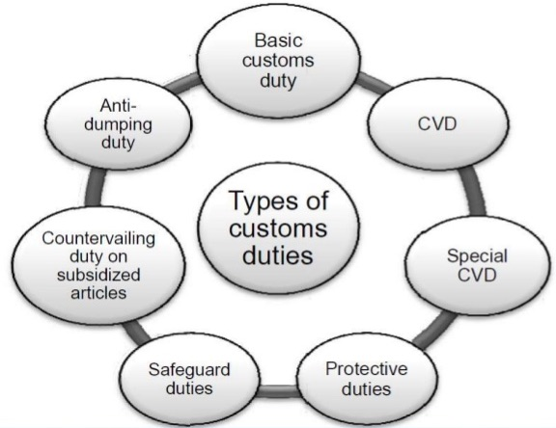

CUSTOMS DUTY

1) Basic Customs Duty:
The Basic Customs Duty is levied under Sec. 12 of the Customs Act, 1962. As per Sec. 2 of the Customs Tariff Act, 1975 preferential rate of duty is always lesser than standard rate of duty. The importer has to satisfy certain conditions to avail the preferential rate of duty on imported goods.
2) Additional Duty of Customs or Countervailing Duty (CVD):
As per Sec. 3(1) of the Customs Tariff Act, 1975 any article which is imported into India is subject to duty (in addition to BCD) equal to the excise duty for the time being leviable on a like article if produced or manufactured in India.
The duty can be levied only if the article is such that it could be manufactured or produced in India. If the article is not produced or manufactured in India, the excise duty that would be leviable on those goods had it been manufactured in India is the base.
However, if goods manufactured in India is exempt from excise duty then there is no additional duty of customs.
3) Special Additional Customs Duty:
The imported goods shall in addition to basic customs duty and additional duty shall also be liable to special additional duty, which shall be levied at a rate to be specified by Central Government. Such rate shall be notified by the Central Government having regard to the maximum sales tax, local tax or any other charge. At present, the special CVD rate is 4%.
4) Protective Duties:
Protective duties are levied by the Central Government upon the recommendations made by the Tariff Committee and upon it being satisfied that circumstances exist which render it necessary to take immediate action to provide protection to any industry established in India. While calculating protective duties, we should not calculate the education cess and secondary and higher education cess. As per WTO, protective duty is not supposed to be levied. Hence at present this duty is not in force.
5) Safeguard duty:
CUSTOMS DUTY

It is imposed for the purpose of protecting the interest of any domestic industry in India. It is product specific. While calculating protective duties we should not calculate the education cess and SHE cess. The Central Government of India can impose provisional safeguard duty pending final determination upto 200 days.
6) Countervailing duty of subsidized articles:
Duty levied if the articles are imported into India by getting the subsidies from other country. While calculating protective duties, we should not calculate the EC and SHEC.
7) Anti Dumping duty:
This duty is country specific. It is imposed on importers of a particular country. Dumping exists when a product is exported from 1 country to another country at an export price is less than its normal value prevailing in the exporting country. The difference between the normal value and the export price is the dumping margin based on which the anti dumping duty is imposed. While calculating protective duties we should not collect the EC and SHEC.
Abatement of duty on damaged or deteriorated goods:
1) Circumstances:
Damage or Deterioration (all Imported goods) | Damage to Imported goods (other than warehoused goods) | Damage to warehoused goods
Imported goods had been damaged or deteriorated at any time before or during the unloading of the goods in India. | Imported goods had been damaged on account of any accident at any time after unloading in India, but before their examination u/s 17 | Warehoused goods damaged at any time on account of any accident, before clearance for home consumption.

CUSTOMS DUTY

Note: Accident should not be due to any (a) willful act (b) negligence (c) default of the importer, his employee or agent.
2) Abatement:
The duty will be reduced proportionately to the reduction in value, if it is shown to the satisfaction of AC or DC that the damage or deterioration had taken place in the above manner.
3) Valuation:
The owner of the goods has the option to choose from any one of the following methods for the valuation of damaged goods –
- Value of goods may be ascertained by the proper officer, or
- Damaged goods may be sold by the proper officer by (i) public auction or (ii) by tender or (iii) in any other manner with the consent of the owner. The gross sale proceeds shall be deemed to be the value of such goods.

Remission on duty on lost, destroyed or abandoned goods – Sec. 23
1. Physical availability:
- Lost / destroyed goods are not physically available.
- Abandoned goods are physically available.
2. Quantity Lost:
- Any quantity
3. Duty liability
- Duty is leviable. But AC / DC may grant remission for lost / destroyed goods.
- Owner not liable to pay duty for abandoned goods.
4. Nature of Benefit:
- Benefit is given by Statute, but discretion is available to AC /DC.
5. Burden of proof:
CUSTOMS DUTY

- Loss / destruction due to natural causes, should be proved by importer.
6. Restoration:
- Restoration is not possible, since goods are physically lost / destroyed.
7. Abandonment:
- Sec. 23 covers situations of abandonment / surrender also.
8. Time point:
- Lost / destroyed any time before clearance for home consumption (either directly or from warehouse)
9. Warehoused goods:
- Applicable to warehoused goods also.

Customs Duty Drawback
The term ‘duty drawback’ means drawing back of the duties paid. As per Sec. 75 of the Customs Act, 1962, drawback is given as an amount to the exporter which represents:
- The duty paid on imported inputs which are used in the manufacture of export goods.
- The excise duty paid on the indigeneously produced inputs used in the manufacture of export goods.
- The service tax paid on input services.
- However, the amount of drawback paid would not exactly relate to the actual import duty and excise duty components. It is determined by the government on the basis of an average amount of duty having regard to all the circumstances and facts of the manufacturing industry.

Goods and services Tax
Goods and services Tax
An Introduction
GST is an Indirect Tax which has replaced many Indirect Taxes in India. The Goods and Service Tax Act was passed in the Parliament on 29th March 2017. The Act came into effect on 1st July 2017; Goods & Services Tax Law in India is a comprehensive, multi-stage, destination-based tax that is levied on every value addition.
In simple words, Goods and Service Tax (GST) is an indirect tax levied on the supply of goods and services. This law has replaced many indirect tax laws that previously existed in India.
GST is one indirect tax for the entire country.
Definition
The definition of Goods and Service Tax – “GST is a comprehensive, multi-stage, destination-based tax that will be levied on every value addition.”
Meaning
The Goods and Services Tax (GST) is a value-added tax levied on most goods and services sold for domestic consumption. The GST is paid by consumers, but it is remitted to the government by the businesses selling the goods and services. In effect, GST provides revenue for the government
HISTORY OF GST IN INDIA
- It has now been more than a decade since the idea of national Goods and Services Tax (GST) was mooted by Kelkar Task Force in 2004. The Task Force strongly recommended fully integrated ‘GST’ on national basis.
- Subsequently, the then Union Finance Minister, Shri P. Chidambaram, while presenting the Central Budget (2007-2008), announced that GST would be introduced from April 1, 2010. Since then, GST missed several deadlines and continued to be shrouded by the clouds of uncertainty.

Goods and services Tax
The talks of ushering in GST, however, gained momentum in the year 2014 when the NDA Government tabled the Constitution (122nd Amendment) Bill, 2014 on GST in the Parliament on 19th December, 2014. The Lok Sabha passed the Bill on 6th May, 2015 and Rajya Sabha on 3rd August, 2016. Subsequent to ratification of the Bill by more than 50% of the States, Constitution (122nd Amendment) Bill, 2014 received the assent of the President on 8thSeptember, 2016 and became Constitution (101stAmendment) Act, 2016,which paved the way for introduction of GST in India.

- In the following year, on 27th March, 2017, the Central GST legislations - Central Goods and Services Tax Bill, 2017, Integrated Goods and Services Tax Bill, 2017, Union Territory Goods and Services Tax Bill, 2017 and Goods and Services Tax (Compensation to States) Bill, 2017 were introduced in Lok Sabha. Lok Sabha passed these bills on 29th March, 2017 and with the receipt of the President’s assent on 12th April, 2017, the Bills were enacted. The enactment of the Central Acts was followed by the enactment of the State GST laws by various State Legislatures. Telangana, Rajasthan, Chhattisgarh, Punjab, Goa and Bihar were among the first ones to pass their respective State GST laws.
- GST is a path breaking indirect tax reform which will create a common national market. GST has subsumed multiple indirect taxes like excise duty, service tax, VAT, CST, luxury tax, entertainment tax, entry tax, etc.
- France was the first country to implement GST in the year 1954. Within 62 years of its advent, about 160 countries across the world have adopted GST because this tax has the capacity to raise revenue in the most transparent and neutral manner.
CONCEPT OF GST
Before we proceed with the finer nuances of Indian GST, let us first understand the basic concept of GST.
- GST is a value added tax levied on manufacture, sale and consumption of goods and services.
- GST offers comprehensive and continuous chain of tax credits from the producer's point/service provider's point upto the retailer's level/consumer’s level thereby taxing only the value added at each stage of supply chain.
- The supplier at each stage is permitted to avail credit of GST paid on the purchase of goods and/or services and can set off this credit against the GST payable on the supply of goods and services to be made by him. Thus, only the final consumer bears the GST charged by the last supplier in the supply chain, with set-off benefits at all the previous stages.
Goods and services Tax
- Since, only the value added at each stage is taxed under GST, there is no tax on tax or cascading of taxes under GST system. GST does not differentiate between goods and services and thus, the two are taxed at a single rate.
NEED FOR GST IN INDIA
Deficiencies in the existing value added taxation has led to GST A cure for ills of existing indirect tax regime
- In the earlier indirect tax regime, a manufacturer of excisable goods charged excise duty and value added tax (VAT) on intra-State sale of goods. However, the VAT dealer on his subsequent intra-State sale of goods charged VAT (as per prevalent VAT rate as applicable in the respective State) on value comprising of (basic value + excise duty charged by manufacturer + profit by dealer). Further, in respect of tax on services, service tax was payable on all ‘services’ other than the Negative list of services or otherwise exempted.
- The earlier indirect tax framework in India suffered from various shortcomings. Under the earlier indirect tax structure, the various indirect taxes being levied were not necessarily mutually exclusive.
To illustrate, when the goods were manufactured and sold, both central excise duty (CENVAT) and State-Level VAT were levied. Though CENVAT and State-Level VAT were essentially value added taxes, set off of one against the credit of another was not possible as CENVAT was a central levy and State Level VAT was a State levy.
- Moreover, CENVAT was applicable only at manufacturing level and not at distribution levels. The erstwhile sales tax regime in India was a combination of origin based (Central Sales Tax) and destination based multipoint system of taxation (State-Level VAT).
Service tax was also a value added tax and credit across the service tax and the central excise duty was integrated at the central level.
- Despite the introduction of the principle of taxation of value added in India - at the Central level in the form of CENVAT and at the State level in the form of State VAT - its application remained piecemeal and fragmented on account of the following reasons:
1)Non-inclusion of several local levies in State VAT such as luxury tax, entertainment tax, etc.
2)Cascading of taxes on account of (i) levy of Non-VAT able CST and (ii) inclusion of CENVAT in the value for imposing VAT.
3)No CENVAT after manufacturing stage
Goods and services Tax
4)Non-integration of VAT & service tax
5)Double taxation of a transaction as both goods and services

- A comprehensive tax structure covering both goods and services viz. Goods and Service Tax (GST) addresses these problems. Simultaneous introduction of GST at both Centre and State levels has integrated taxes on goods and services for the purpose of set-off relief and ensures that both the cascading effects of CENVAT and service tax are removed and a continuous chain of set-off from the original producer’s point/ service provider’s point up to the retailer’s level/ consumer’s level is established.
- In the GST regime, the major indirect taxes have been subsumed in the ambit of GST. The erstwhile concepts of manufacture or sale of goods or rendering of services are no
longer applicable since the tax is now levied on “Supply of Goods and/or services”.
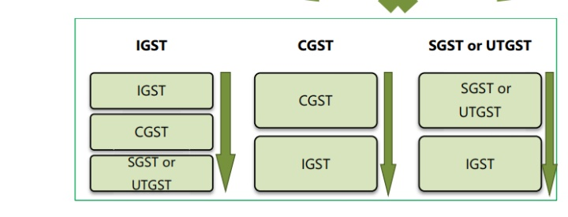
FRAMEWORK OF GST AS INTRODUCED IN INDIA
I. Dual GST:
India has adopted a dual GST which is imposed concurrently by the Centre and States, i.e. Centre and States simultaneously tax goods and services. Centre has the power to tax intra-State sales & States are empowered to tax services. GST extends to whole of India including the State of Jammu and Kashmir

Goods and services Tax
II. CGST/SGST/UTGST/IGST
- GST is a destination based tax applicable on all transactions involving supply of goods and services for a consideration subject to exceptions thereof. GST in India comprises of Central Goods and Service Tax (CGST) - levied and collected by Central Government, State Goods and
Service Tax (SGST) - levied and collected by State Governments/Union Territories with State Legislatures and Union Territory Goods and Service Tax (UTGST) - levied and collected by Union Territories without State Legislatures, on intra-State supplies of taxable goods and/or services.
- Inter-State supplies of taxable goods and/or services are subject to Integrated Goods and Service Tax (IGST). IGST is approximately the sum total of CGST and SGST/UTGST and is levied by Centre on all inter-State supplies.
III. Legislative Framework
- There is single legislation – CGST Act, 2017 - for levying CGST. Similarly, Union Territories without State legislatures [Andaman and Nicobar Islands, Lakshadweep, Dadra and Nagar Haveli, Daman and Diu and Chandigarh] are governed by UTGST Act, 2017 for levying UTGST. States and Union territories with their own legislatures [Delhi and Puducherry] have their own GST legislation for levying SGST.
- Though there are multiple SGST legislations, the basic features of law, such as chargeability, definition of taxable event and taxable person, classification and valuation of goods and services, procedure for collection and levy of tax and the like are uniform in all the SGST legislations, as far as feasible. This is necessary to preserve the essence of dual GST.
IV. Classification of goods and services
- HSN (Harmonised System of Nomenclature) code is used for classifying the goods under the GST.
- A new Scheme of Classification of Services has been devised wherein the services of various descriptions have been classified under various sections, headings and groups. Each group consists of various Service Codes (Tariff). Chapters referred are the Chapters of the First Schedule to the Customs Tariff Act, 1975.
V. Registration

Goods and services Tax
- Every supplier of goods and/ or services is required to obtain registration in the State/UT from where he makes the taxable supply if his aggregate turnover exceeds ` 20 lakh during a FY.
- However, the limit of ` 20 lakh will be reduced to ` 10 lakh if the person is carrying out business in the Special Category States – [11 Special Category States are specified in Article 279A(4)(g) of the Constitution] - States of Arunachal Pradesh, Assam, Jammu and Kashmir, Manipur, Meghalaya, Mizoram, Nagaland, Sikkim, Tripura, Himachal Pradesh and Uttarakhand.
VI. Composition Scheme
- In GST regime, tax (i.e. CGST and SGST/UTGST for intra-State supplies and IGST for inter-State supplies) is payable by every taxable person and in this regard provisions have been prescribed in the law.
- However, for providing relief to small businesses making intra-State supplies, a simpler method of paying taxes and accounting thereof is also prescribed, known as Composition Levy.
VII. Exemptions
- Apart from providing relief to small-scale business, the law also contains provision for granting exemption from payment of tax on essential goods and/or services.
VIII. Manner of utilization of ITC
- Input Tax Credit (ITC) of CGST and SGST/UTGST is available throughout the supply chain, but cross utilization of credit of CGST and SGST/UTGST is not possible, i.e. CGST credit cannot be utilized for payment of SGST/UTGST and SGST/UTGST credit cannot be utilized for payment of CGST.
- However, cross utilization is allowed between CGST/SGST/UTGST and IGST, i.e. credit of IGST can be utilized for the payment of CGST/SGST/UTGST and vice versa.

Goods and services Tax
IX. Seamless flow of credit
- Since GST is a destination based consumption tax, revenue of SGST ordinarily accrues to the consuming States. The inter-State supplier in the exporting State is allowed to set off the available credit of IGST, CGST and SGST/UTGST (in that order) against the IGST payable on inter-State supply made by him.
- The buyer in the importing State is allowed to avail the credit of IGST paid on inter-State purchase made by him. Thus, unlike the earlierscenario where the credit chain used to break in case of inter-State sales on account of non-VATable CST, under GST regime there is a seamless credit flow in case of inter-State supplies too.
- The revenue of inter-State sale does not accrue to the exporting State and the exporting State transfers to the Centre the credit of SGST/UTGST used in payment of IGST.
- The Centre transfers to the importing State the credit of IGST used in payment of SGST/UTGST. Thus, the inter- State trade of goods and services (IGST) needed a robust settlement mechanism amongst the States and the Centre.
- A Common Portal was needed which could act as a clearing house and verify the claims and inform the respective Governments to transfer the funds. This was possible only with the help of a strong IT Infrastructure.
X. GST Common Portal
- Resultantly, Common GST Electronic Portal – www.gst.gov.in – a website managed by Goods and Services Network (GSTN) [a company incorporated under the provisions of section 8 of the Companies Act, 2013] has been set by the Government to establish auniform interface for the tax payer and a common and shared IT infrastructure between the Centre and States.
- The GST portal is accessible over Internet (by taxpayers and their CAs/Tax Advocates etc.) and Intranet by Tax Officials etc. The portal is one single common portal for all GST related services.
- A common GST system provides linkage to all State/ UT Commercial Tax Departments, Central Tax authorities, Taxpayers, Banks and other stakeholders. The eco-system consists of all stakeholders starting from taxpayer to tax professional to tax officials to GST portal to Banks to accounting authorities.
- Primarily, GSTN provides three front end services to the taxpayers namely registration, payment and return through GST Common Portal.
Goods and services Tax
- The functions of the GSTN include:
- facilitating registration;
- forwarding the returns to Central and State authorities;
- computation and settlement of IGST;
- matching of tax payment details with banking network;
- providing various MIS reports to the Central and the State Governments based on the taxpayer return information;
- providing analysis of taxpayers' profile; and running the matching engine for matching, reversal and reclaim of input tax credit.

XI. GSPs/ASPs
- GSTN has selected certain IT, ITeS and financial technology companies, to be called GST Suvidha Providers (GSPs). GSPs develop applications to be used by taxpayers for interacting with the GSTN.
- They facilitate the tax payers in uploading invoices as well as filing of returns and act as a single stop shop for GST related services.
They customize products that address the needs of different segment of users. GSPs may take the help of Application Service Providers (ASPs) who act as a link between taxpayers and GSPs
Benefits of GST
A. To the Society and country
1. Unified common national market will attract more foreign investment. GST has integrated the economy of all States and Union Territories.
2. It brings parity in taxation among imported goods and Indian manufactured goods. All imported goods will be charged with IGST which will be more or less equivalent to the total of CGST and SGST levied on manufactured goods. Removal of several taxes will make the price of Indian products more competitive at world market.
3. It will boost manufacturing, export, GDP leading to economic growth through increase in economic activity.
4. Creation of more employment opportunities which will result in poverty eradication.
5. It will bring more tax compliance (more tax payers) and increase revenue to the Governments.
Goods and services Tax
6. It is transparent and will improve India’s ranking in the ‘Ease of Doing Business’ in the world.
7. Uniform rates of tax will reduce tax evasion and rate arbitrage between States.

B. To Business Community
1. Simpler Tax System with fewer exemptions. 17 taxes were abolished and one tax exists today.
2. Input tax credit will reduce cascading effect of taxes. Reduction in average tax burden will encourage manufacturers and help “Make in India” campaign and make India as a manufacturing hub.
3. Common procedures, common classification of goods and services and timelines will lend greater certainty to taxation system.
4. GSTN facility will reduce multiple record keeping, lesser investment in manpower and resources and improve efficiency.
5. All interactions will be through common GSTN portal and will ensure corruption free administration.
6. Uniform prices throughout the country. Expansion of business to all states is made easy.
C. To Consumers
1. Input tax credit allowed will lower the prices to the consumers.
2. All small retailers will get exemption and purchases from them will cost less for the consumers.
Disadvantages of GST
Besides the above listed advantages the GST is also criticized for many reasons. The disadvantages of GST are stated below:
i. Several Economists says that GST in India would impact negatively on the real estate market. It would add up to 8 percent to the cost of new homes and reduce demand by about 12 percent.
ii. Another criticism is that CGST, SGST are nothing but new names for Central Excise/Service Tax, VAT and CST. Hence, there is no major reduction in the number of tax layers.
iii. A number of retail products currently have only four percent tax on them. After GST, garments and clothes could become more expensive.
iv. The aviation industry would be affected. Service taxes on airfares currently range from six to nine percent. With GSTthis rate will surpass fifteen percent and effectively double the tax rate.
Goods and services Tax
v. Adoption and migration to the new GST system would involve teething troubles and learning for the entire ecosystem

TAX RATES UNDER GST IN INDIA
The government has raised the goods and services tax on items such as clothes, textiles, and footwear from 5% to 12%. The GST rate on textiles has been raised to 12% from 5%, and the GST rate on garments of any value has been raised to 12% from 5%.

Goods and services Tax

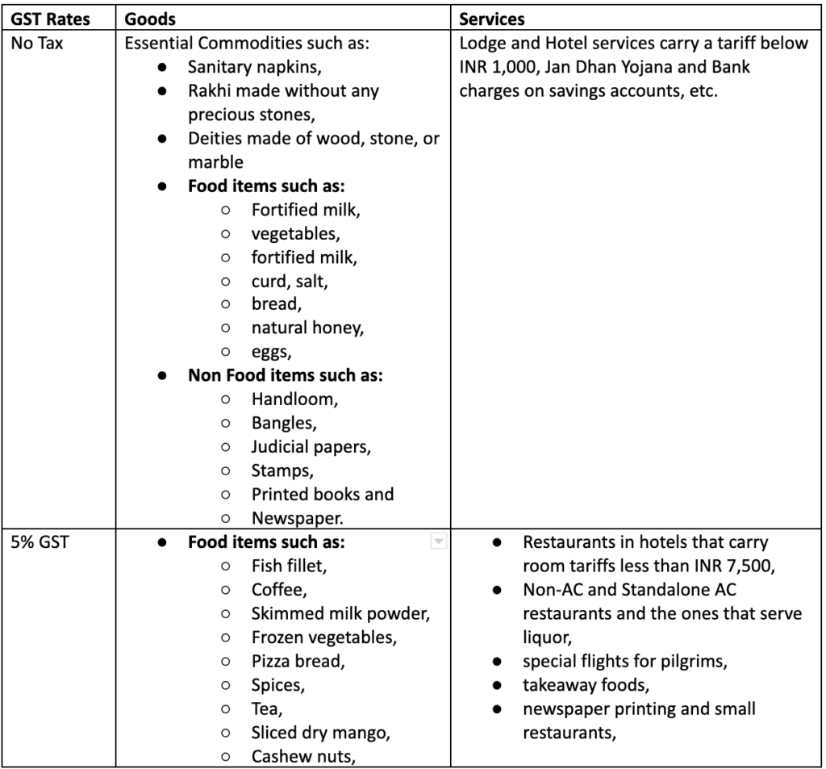
Classifications of items under the several GST rate slabs

Goods and services Tax

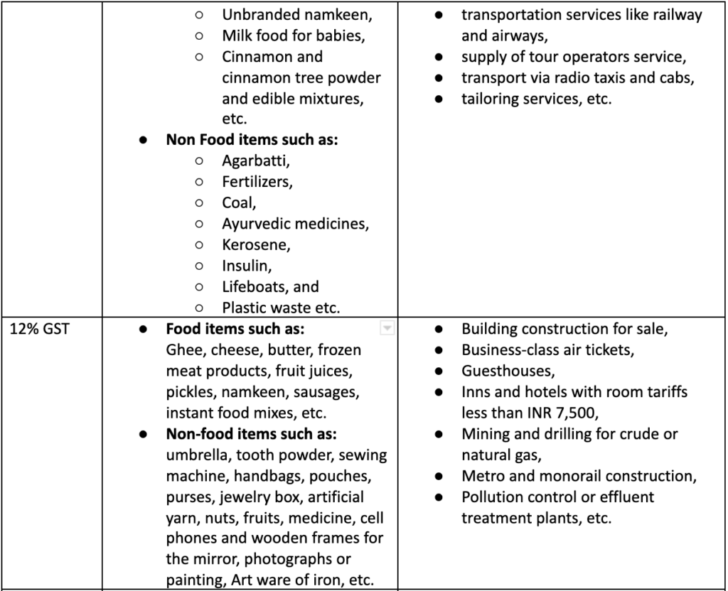

Goods and services Tax

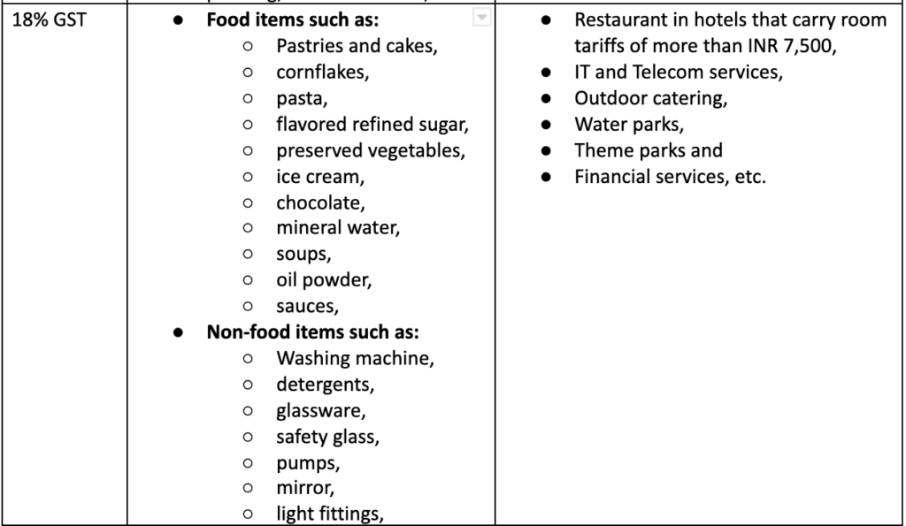
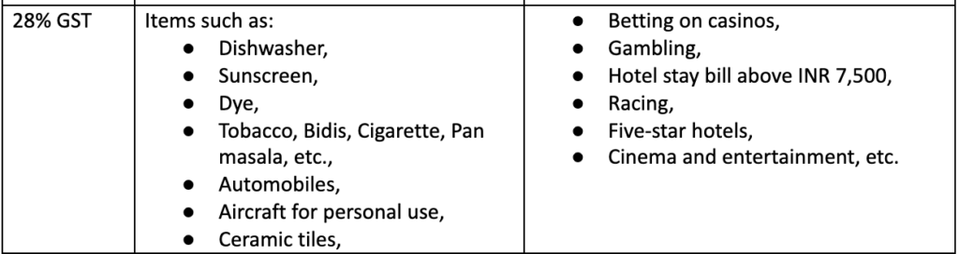
Supply and Its Forms
Supply and Its Forms
Introduction
Power to levy tax is drawn from the Constitution of India. Introduction of GST necessitated the Constitutional amendment to enable integration of the central excise duty including additional duties of customs, State VAT and certain State specific taxes and service tax levied by the Centre into a comprehensive goods and services tax .
Meanings of important terms:
1.Goods:
Goods means every kind of movable property other than money and securities but includes actionable claim, growing crops, grass and things attached to or forming part of the land which are agreed to be severed before supply or under a contract of supply. [Sec. 2(52) of CGST Act].
2.Services:
Services means anything other than goods, money and securities but includes activities relating to the use of money or its conversion by cash or by any other mode, from one form, currency or denomination, to another form, currency or denomination for which a separate consideration is charged. [Section 2(102) of CGST Act].
3.Supplier:
Supplier in relation to any goods or services or both, shall mean the person supplying the said goods or services or both and shall include an agent acting as such on behalf of such supplier in relation to the goods or services or both supplied. [Section 2(105) of CGST Act].
4.Business:
[Section 2(17) of CGST Act].
Business: includes –
(a) any trade, commerce, manufacture, profession, vocation, adventure, wager or any other similar activity, whether or not it is for a pecuniary benefit;
(b) any activity or transaction in connection with or incidental or ancillary to (a)
Supply and Its Forms
above;
(c) any activity or transaction in the nature of (a) above, whether or not there isvolume, frequency, continuity or regularity of such transaction;
(d) supply or acquisition of goods including capital assets and services in connection with commencement or closure of business;
(e) provision by a club, association, society, or any such body (for a subscription or any other consideration) of the facilities or benefits to its members, as the case may be;
(f) admission, for a consideration, of persons to any premises; and
(g) services supplied by a person as the holder of an office which has been accepted by him in the course or furtherance of his trade, profession or vocation;
(h) services provided by a race club by way of totalisator or a licence to book maker in such club
(i) any activity or transaction undertaken by the Central Government, a State Government or any local authority in which they are engaged as public authorities
5.Manufacture:
“manufacture” means processing of raw material or inputs in any manner that results in emergence of a new product having a distinct name, character and use and the term “manufacturer” shall be construed accordingly;[Sec 2(72) of CGST].
6.causal Taxable person:
“casual taxable person” means a person who occasionally undertakes transactions involving supply of goods or services or both in the course or furtherance of business, whether as principal, agent or in any other capacity, in a State or a Union territory where he has no fixed place of business;[Sec 2(20) of CGST act].
7.Aggregate Turnover
Aggregate turnover means the aggregate value of all taxable supplies (excluding the value of inward supplies on which tax is payable by a person on reverse charge basis), exempt supplies, exports of goods or services or both and inter-State supplies of persons having the same Permanent Account be computed on all India basis but excludes central tax, State tax, Union territory tax, integrated tax and cess [Section 2(6) of CGST Act].
8.Input Tax
Supply and Its Forms
“input tax” in relation to a registered person, means the central tax, State tax, integrated tax or Union territory tax charged on any supply of goods or services or both made to him and includes—
(a) the integrated goods and services tax charged on import of goods;
(b) the tax payable under the provisions of sub-sections (3) and (4) of section 9;
(c) the tax payable under the provisions of sub-sections (3) and (4) of section 5 of the Integrated Goods and Services Tax Act;
(d) the tax payable under the provisions of sub-sections (3) and (4) of section 9 of the respective State Goods and Services Tax Act; or
(e) the tax payable under the provisions of sub-sections (3) and (4) of section 7 of the Union Territory Goods and Services Tax Act,
but does not include the tax paid under the composition levy;[Sec 2(62)of CGST act].
9.Output Tax
“output tax” in relation to a taxable person, means the tax chargeable under this Act on taxable supply of goods or services or both made by him or by his agent but excludes tax payable by him on reverse charge basis;[Sec 2(82) of CGST Act].

Supply of goods or services
When a transaction takes place, if there is a transfer of title of goods, then it is considered as supply of goods. For example, when you buy a pen from a retailer, the ownership of the pen is transferred from the retailer to you, the customer.
When there is a transfer of right in goods without transfer of title, it is considered as supply of service. For example, if you are availing transportation services, then the right of using the service is transferred to you, while the ownership still stays with the transportation company.

Supply and Its Forms

Supply should be taxable
Supply of goods or services can either be taxable or tax-exempt. Taxable supplies are goods and services that attract GST. Tax-exempt supplies include supply of goods or services that belong to a specific category mentioned in the GST Act.

Supply should be made by a taxable person
A taxable person is defined as a person who is registered under the GST, or is a liable to register, or a person who has voluntarily registered.
Supply between two non-taxable people will not be considered as supply under GST.
If a person supplies goods or services in different states or has multiple business verticals, then they are required to register separately for each state or vertical. Each of these registered entities will be considered as a taxable person.

Supply should be made within a taxable territory
Taxable territory means any place in India except the State of Jammu and Kashmir.

Supply should be made in exchange for consideration
Consideration can be defined as a barter of goods or services, or payment made for a supply in money, or in kind. A prepayment or deposit toward a supply is also as accepted as a consideration by the government.
According to CGST Act, the following activities that will be treated as supply even if it is made without consideration.
- When a business permanently transfers or disposes its assets for which input tax credits have been availed.
- Supply made between two related or separate persons for business purposes.
- Supply of goods by an agent on behalf of the supplier or supply received by an agent on behalf of a customer.
- When a taxable person imports services from a related person, or from his or her own business outside of India for business purposes.
Supply and Its Forms

Supply should be made in the course of business or in the interest of growing a business
GST is applicable only on business transactions. Hence, for a transaction to be a considered as supply under GST, it has to be made for business purposes.
If supplies are made for personal purposes, it will not be considered as a supply under GST.

Three components of supply under GST
A supply under GST has three attributes that are used to calculate the tax owed for that transaction: place, value, and time.
- Place of Supply - This component determines whether a transaction is an intra-state supply, an inter-state supply, or an external trade, which determines the type of GST that will be associated with it.
- Value of Supply - This component decides the taxable value of supply made, and thus the amount of tax that needs to be paid for it.
- Time of Supply - This component determines when the associated taxes and GST returns are due.

Types of supply under GST
Under the GST, supply of goods and/or services can be classified into two major categories - Taxable supplies and Non-taxable supplies. These are further classified into different types based on the nature of supply made.
- Taxable Supplies - These refer to supply of goods and/or services that are taxable under GST. Registered taxpayers can claim refunds on tax paid during purchases (in other words, they are eligible for ITC).
  - Regular taxable supplies - Whenever you supply an item or service which attract a GST rate greater than 0% within India, it becomes a regular taxable supply.

Supply and Its Forms
  - Nil-rated supplies - Whenever you supply goods which attract 0% GST by default, such supplies are known as nil rated supplies.
  - Zero-rated supplies - Whenever you make exports, supplies to a SEZ unit or deemed exports, the GST associated with the items or services involved becomes 0 even though the same would attract a GST rate greater than 0% when sold within India. Such supplies are deemed as zero rated supplies

Non Taxable Supplies
  - Exempt Supplies - The supply of exempt goods or services do not attract GST even though they are within the purview of GST. That said, the registered taxpayer cannot claim ITC on inputs used for making such supplies.
  - Non-GST supplies - This refers to supply of items which are outside the purview of the GST law.
Note: The following transactions must neither be considered as a supply of goods nor services: Supply of goods from one non-taxable territory to another without entering India. Supply of warehoused goods to a buyer before they pass clearance for home consumption. Supply of goods related to high sea sales.

Concept of Supply (Section 7 ofCGST)

Scope of supply: section 7 of the CGST Act as amended by the CGST Amendment Act 2018
Supply and Its Forms
Section 7 of the Central Goods and Services Tax (CGST) Act, 2017 outlines the “Scope of Supply” under the Act, which is an essential element for the levy and collection of tax under the CGST Act:

Section 7(1) of the CGST Act
Subsection (1) defines “supply” as including:
a) All forms of supply of goods or services or both, such as sale, transfer, barter, exchange, license, rental, lease or disposal made or agreed to be made for a consideration by a person in the course or furtherance of business.
(aa) Activities or transactions by a person (other than an individual) to its members or constituents or vice-versa, for cash, deferred payment or other valuable consideration. The explanation clarifies that the person and its members or constituents are considered separate entities and transactions between them are considered supplies.
b) Import of services for a consideration, regardless of whether it is in the course or furtherance of business.
c) Activities specified in Schedule I, made or agreed to be made without a consideration

Section 7(1A) of the CGST Act
Subsection (1A) explains that if certain activities or transactions constitute a supply as per subsection (1), they shall be treated as either a supply of goods or supply of services, as referred to in Schedule II.

Section 7(2) of the CGST Act
Subsection (2) states that activities or transactions specified in Schedule III or those undertaken by the Central Government, a State Government or any local authority as public authorities (as notified by the Government based on the recommendations of the Council) are treated neither as a supply of goods nor a supply of services.

Section 7(3) of the CGST Act
Subsection (3) allows the Government, based on the recommendations of the Council, to specify transactions by notification that are to be treated as:
a) A supply of goods and not as a supply of services; or
Supply and Its Forms
b) A supply of services and not as a supply of goods.
In summary, Section 7 of the CGST Act, 2017, provides a comprehensive definition of “supply,” which forms the basis for the levy of the CGST. It also clarifies the treatment of certain transactions as either a supply of goods or services and specifies activities that are not considered supplies under the Act.
Composite and Mixed Supplies (Section 8)

Section 8(a) of the CGST Act: Composite Supply
A composite supply refers to a bundle of two or more supplies where one of them is a principal supply. According to Section 8(a), the tax liability on a composite supply will be treated as a supply of the principal supply.
A popular example of composite supply is the supply of a laptop with pre-installed software. In this case, the laptop is the principal supply and the software is the secondary supply. As per Section 8(a), the tax liability on this composite supply will be determined based on the tax rate applicable to the laptop (principal supply), regardless of the tax rate on the software.

Section 8(b) of the CGST Act: Mixed Supply
Mixed supply, on the other hand, refers to a bundle of two or more supplies that are not necessarily dependent on each other or bundled due to a natural necessity. Section 8(b) states that the tax liability on a mixed supply will be determined based on the supply which attracts the highest rate of tax.
For example, let’s consider the case of a gift hamper that contains chocolates, a soft toy and a perfume. These items are not naturally bundled or dependent on each other. In this case, the tax liability will be determined by the item with the highest tax rate. Suppose the tax rates are 12% for chocolates, 18% for the soft toy and 28% for the perfume. The tax rate for the entire gift hamper will be considered as 28% (the highest rate), as per Section 8(b).
In conclusion, Section 8 of the CGST Act, 2017 provides guidelines for determining tax liability on composite and mixed supplies. The tax liability on composite supplies is determined based on the principal supply, while the tax liability on mixed supplies is determined based on the supply with the highest tax rate.
Incidence of Tax
Incidence of Tax
Incidence of Tax
"Tax incidence" (or incidence of tax) is an economic term for understanding the division of a tax burden between stakeholders, such as buyers and sellers or producers and consumers. Tax incidence can also be related to the price elasticity of supply and demand. When supply is more elastic than demand, the tax burden falls on the buyers. If demand is more elastic than supply, producers will bear the cost of the tax.
Goods Exempt from Tax

After 1st July 2017, the Government of India set up some criterias upon fulfilling which businesses and individuals have to register under GST norms.
However, certain goods and services can enjoy exemption from GST registration. Furthermore, the supply of some goods or services attracts a nil rate of tax which in short is also known as exempt supply under GST.
To understand the finer details of the GST exemption, it is necessary to follow the GST exemption list.
Therefore, we present this piece to simplify the meaning of what is exempt from GST and which services or products are exempted from registration under GST.

What is a GST exemption?
Understanding the taxability of goods and services also includes knowing whether a good or service is exempted from GST registration. Upon knowing this, applicants can get clarity on several other factors. Essentially, the GST exemption limit for businesses depends on their annual aggregate turnover.
A businesses with an annual turnover of up to Rs.20 lakhs did not need to register for GST. The amount was Rs.10 lakhs for North-eastern or hilly states like Meghalaya, Sikkim, Mizoram, Arunachal Pradesh, Nagaland, Himachal Pradesh, Manipur, Assam, Tripura, Uttarakhand, and Jammu & Kashmir.
Incidence of Tax
However, as per the GST council meeting on 10th January 2019, the values doubled for Micro, Small, and Medium Enterprises (MSMEs) in both cases.
In addition to this, certain supplies of goods and services fall under the GST registration exemption list.

What is an exempt supply under GST?
There are three types of supplies that can enjoy exemption under GST. They are as follows:
- Supplies taxable at 0% tax or nil tax rate.
- Whole or partial exemption of supplies under CGST or SGST.
- Supplies under Section 2(78).
Note: One cannot utilise the input tax credit applicable to these supplies.
In addition to this, one must follow the list mentioned below to understand the differences between nil-rated, zero-rated, exempt and non-GST supplies.
Supplies | Meaning
Nil-rated | Supplies that have 0% tax rate. Example: Salt
Non-GST | Ones that do not come under the purview of GST law include alcohol for human consumption
Zero-rated | Export supplies to SEZ (Special Economic Zone) developers.
Exempt | Taxable supplies that do not attract GST. Curd, fruits are among some of the supplies.

Types of exemption in GST
Given below are the three types of exemptions in GST:
- Absolute: Exemptions without any conditions are an absolute exemption. For example, services by the RBI.

Incidence of Tax
Conditional: Certain conditions are applicable to some exemptions. Services by hotels, clubs, etc., with a statement of accommodation unit less than Rs.1000 per day, fall under a conditional exemption.
- Partial: Unregistered persons supplying goods within states (intrastate) to a registered individual can enjoy tax exemption under reverse charge only if the aggregate value of a supply does not exceed Rs.5000 per day.
Now let us delve deeper into the GST exempt items.

List of GST exemption
Goods, services, supplies, businesses, and individuals must register for GST provided they fulfill certain conditions. However, there are few exceptions to this. In the following section, you will find a list mentioning all the items, businesses, and taxpayers who can avail of tax exemption under the Goods and Services Tax regime.

GST exemption from registration
The following category of taxpayers need not register for GST:
- Individuals belonging to the threshold exemption limit.
- Exempt suppliers of goods and services.
- A person supplying non-GST goods and services.
- Taxpayers engaging in activities other than the supply of goods or services.
- Agriculturists.
- Ones supplying goods covered under reverse charge.
Therefore, if you belong to the above list, you can enjoy a full GST exemption

GST exemption for start-ups and small businesses
Individuals aspiring to start a business can benefit greatly from the latest regulations of the GST scheme. Here are a few pointers to keep in mind regarding GST exemption for start-ups.
- Any business with a turnover of less than Rs.40 lakhs is recognised as a GST-exempt business.
Incidence of Tax
- Businesses that have a lower annual aggregate turnover than Rs.1.5 crores can avail of a composition scheme under GST. The scheme allows individuals to pay taxes at a fixed rate depending on the turnover amount. The rate may vary between 1-6%.
- Also, small businesses are exempted from e-invoicing under GST. However, businesses with a turnover of more than Rs.50 crores have to apply for e-invoicing mandatorily.
- Small businesses with an income below Rs.5 crores can opt for a quarterly filing system.
Hence, it is evident that small businesses can accrue several benefits under this new tax scheme

Exempted goods under GST
In the following section, you will find a list of the GST exempted goods in India:
- Fresh and dry vegetables like potatoes, onions, and other leguminous vegetables.
- Non-GST goods include fish, egg, fresh milk, etc.
- Grapes, melons, ginger, garlic, unroasted coffee beans, green tea leaves that are not processed, and more.
- Food items that are not put into branded containers like rice, hulled cereal grains, wheat, corn, etc.
- Components like human blood.
- Unspun jute fibres, raw silk, khadi fibre, etc.
- Hearing aid manufacturing parts, chalks, slates, handloom, etc.
Note: Certain non-GST items, once processed, will attract a GST.

Exempted services under GST
A number of services qualify for GST exemption. Here is a GST exemption list of services for your reference:
- Agricultural services, including harvesting, packaging, warehouse, cultivation, supply, leasing of machinery, are essentially GST exempt services. An exception to these exempted services includes the rearing of horses.
- Public transportation services, auto-rickshaws, metered cabs, metro, etc.
- Transportation of agricultural products and goods outside of India.
Incidence of Tax
- Labour supply for farms.
- Goods transportation where the charges are less than Rs.1500.
- Services like retail packing, pre-conditioning, waxing, etc.
- Foreign diplomatic and government services.
- Healthcare and educational services like mid-day meal catering, VET clinics, paramedics, etc. Ambulance and charity services also qualify for exemption under GST.
- Services offered by RBI, IRDAI, Central and State Government, NPS and more.
- Banking services like Basic Saving Bank Deposit (BSBD) account operable under the Pradhan Mantri Jan-Dhan Yojana (PMJDY).
In addition to this, services related to religious ceremonies, sports organisation, tour guides, and libraries are exempted under GST.
However, one might wonder why these goods and services enjoy exemption from GST registration. One should know about the reasons for exemption as well.

Reasons for exemption under GST
The government decides on exempting goods from registering under GST in the following cases:
- In case the GST council recommends the exemption.
- The government might find certain exemptions from GST registration to be beneficial for the public.
- Under exceptional or unforeseen situations, the government might grant exemption by special order.
- Upon providing official notification, one can supply specific goods under a full exemption.
Therefore, from the points mentioned above, it is evident that several sectors can qualify for a GST exemption provided they fulfill some prerequisites. Knowing those criterias in detail will help a taxpayer to register under GST without any hassle.
Section 11 of CGST Act 2017: Power to Grant Exemption from Tax

Incidence of Tax
(1) Where the Government is satisfied that it is necessary in the public interest so to do, it may, on the recommendations of the Council, by notification, exempt generally, either absolutely or subject to such conditions as may be specified therein, goods or services or both of any specified description from the whole or any part of the tax leviable thereon with effect from such date as may be specified in such notification.
(2) Where the Government is satisfied that it is necessary in the public interest so to do, it may, on the recommendations of the Council, by special order in each case, under circumstances of an exceptional nature to be stated in such order, exempt from payment of tax any goods or services or both on which tax is leviable
The power to grant exemptions from tax
It outlines the conditions under which the government can provide exemptions from CGST on the supply of goods or services or both:
i) Power to grant exemptions: Section 11 empowers the government to grant exemptions from CGST on the supply of goods or services or both. These exemptions can be granted generally (through notification) or in specific cases (through special order).
ii) Conditions for granting exemptions: The government can grant exemptions when it is satisfied that it is necessary in the public interest to do so. The exemptions must also be based on the recommendations of the GST Council.
iii) Notification for general exemptions: If the government decides to grant general exemptions, it can issue a notification specifying the goods or services or both that are exempt, either absolutely or subject to specified conditions. The notification will also specify the date from which the exemption will be effective.
iv) Special order for specific exemptions: In exceptional circumstances, the government can also issue a special order to exempt specific goods or services or both from the tax. The circumstances warranting the exemption must be mentioned in the order.
v) Explanation to notifications or orders: If the government deems it necessary or expedient to clarify the scope or applicability of any notification or order, it may insert an explanation in the notification or order. The

Incidence of Tax
explanation can be inserted within one year of the issue of the notification or order, and it will have retrospective effect as if it had always been a part of the original notification or order.
Section 11 of the CGST Act 2017 provides the government with the authority to grant exemptions from CGST on the supply of goods or services or both. These exemptions can be granted either generally or in specific cases when it is deemed necessary in the public interest and are based on the recommendations of the GST Council.
Input Tax Credit (ITC) under GST
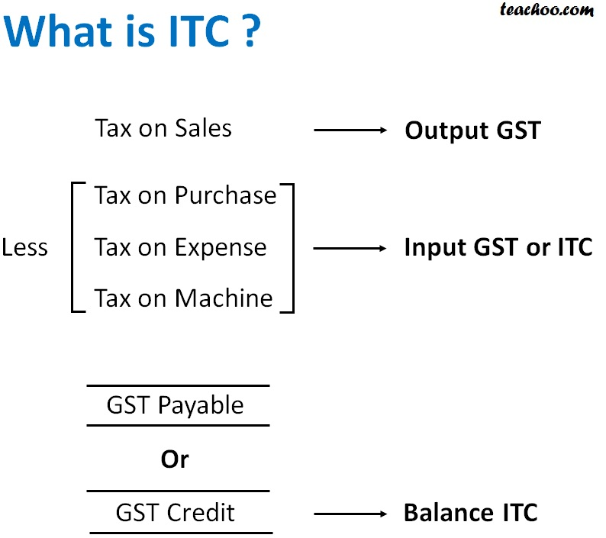
Input credit means at the time of paying tax on output, you can reduce the tax you have already paid on inputs and pay the balance amount.
When you buy a product/service from a registered dealer you pay taxes on the purchase. On selling, you collect the tax. You adjust the taxes paid at the time of purchase with the amount of output tax (tax on sales) and balance liability of tax (tax on sales minus tax on purchase) has to be paid to the government. This mechanism is called utilization of input tax credit.
For example- you are a manufacturer: a. Tax payable on output (FINAL PRODUCT) is Rs 450 b. Tax paid on input (PURCHASES) is Rs 300 c. You can claim INPUT CREDIT of Rs 300 and you only need to deposit Rs 150 in taxes.
Incidence of Tax

How does it work?
At each stage of the supply chain, the buyer gets credit for the input tax paid, and they can use it to offset the GST that needs to be paid to the Centre and State governments. To understand this concept better, let’s take the example of a company called MK Kitchen Knives which sells custom-made kitchen knives.
- They purchase steel and plastic worth Rs.2000 from a vendor at a GST rate of 12.5%. Thus, the input tax they pay is Rs.250.
- The company now sells the manufactured knives for Rs.4000, plus an output tax of 12.5%, making the total selling price Rs.4500 (Rs.4000 + Rs.500).
Thus, the tax that MK Kitchen Knives owes to the Government = Output tax - Input tax credit = Rs.500 - Rs.250 = Rs.250

GST Input Tax Credit Rules
Businesses need to adhere to the following rules to claim input tax credit.
- The buyer must possess a valid tax invoice, debit note, or other prescribed document issued by a registered dealer.
- The buyer must have received the good or service. If the product is being received in instalments, then the credit can be claimed against the tax invoice for the last instalment.
- The supplier must have paid the tax due on the buyer’s purchases to the government either in cash or by claiming input tax credit.
- Finally, the supplier must have filed GST returns. The most unique and unprecedented change GST brings to this entire tax setup is that you are allowed to claim input tax credit on your purchases only if your supplier is GST compliant and has paid the tax they had collected from you.
- Availing ITC for invoices and debit notes apply only in cases where details of these invoices / debit notes are provided in Form GSTR-1 / IFF and communicated to the registered person in Form GSTR-2B. This is applicable only after section 16(2) (aa) of CGST Act, 2017 is notified.

Incidence of Tax
- To claim ITC, the buyer should pay the supplier for the supplies received (inclusive of tax) within 180 days from the date of issuing the invoice. If the buyer fails to do so, the amount of credit they would
- have availed, will be added to their output tax liability. Once the buyer pays the amount due to the supplier by the taxpayer, they will be able to avail ITC. In case of partial payment, credits proportionate to the payment can be availed.
- Motor vehicles used to transport people (seating capacity of more than thirteen including driver), vessels and aircrafts, and money for or by a banking company or financial institution.
- General insurance, repair and maintenance with respect to motor vehicles, vessels and aircrafts.
- Goods or services that are mandatory for an employer to provide to their employees, under any law.

Ineligible to claim ITC
ITC cannot be claimed in the following cases:
- Purchase of capital goods used for non-business purposes.
- Composition dealers
- Purchase of capital goods used for manufacturing exempted goods
- Blocked credits [Section17 (5)]
Note: If taxpayers have availed and used ineligible ITC, interest of 18% has to be paid. Interest need not be paid if ineligible ITC is only availed, without being used.

Incidence of Tax

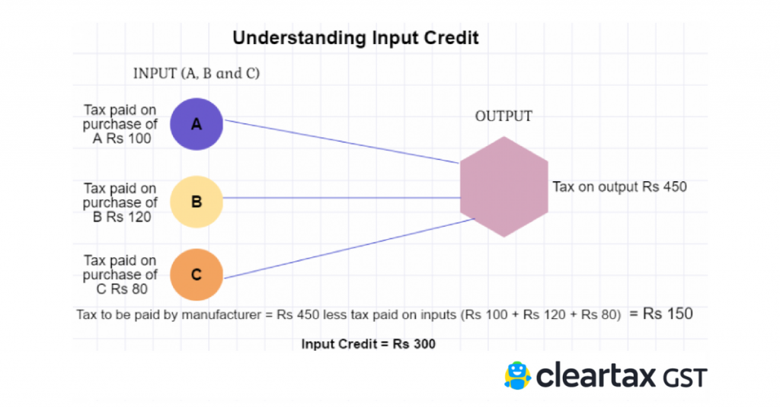

Who can claim ITC?
ITC can be claimed by a person registered under GST only if he fulfils ALL the conditions as prescribed.
a. The dealer should be in possession of tax invoice
b. The said goods/services have been received
c. Returns have been filed.
d. The tax charged has been paid to the government by the supplier.
e. When goods are received in installments ITC can be claimed only when the last lot is received.
f. No ITC will be allowed if depreciation has been claimed on tax component of a capital good
A person registered under composition scheme in GST cannot claim ITC.
Incidence of Tax
What can be claimed as ITC?
ITC can be claimed only for business purposes. ITC will not be available for goods or services exclusively used for: a. Personal use b. Exempt supplies c. Supplies for which ITC is specifically not available
How to claim ITC?
All regular taxpayers must report the amount of input tax credit(ITC) in their monthly GST returns of Form GSTR-3B. The table 4 requires the summary figure of eligible ITC, Ineligible ITC and ITC reversed during the tax period. The format of the Table 4 is given below: A taxpayer can claim ITC on a provisional basis in the GSTR-3B to an extent of 20% of the eligible ITC reported by suppliers in the auto-generated GSTR-2A return. Hence, a taxpayer should cross-check the GSTR-2A figure before proceeding to file GSTR-3B. A taxpayer could have claimed any amount of provisional ITC until 9 October 2019. But, the CBIC has notified that from 9 October 2019, a taxpayer can only claim not more than 20% of the eligible ITC available in the GSTR-2A as provisional ITC. This means taht the amount of ITC reported in the GSTR-3B from 9 October 2019 will be the total of the actual ITC in GSTR-2A and the provisional ITC being 20% of the actual eligible ITC in the GSTR-2A. Hence, matching of the purchase register or expense ledger with the GSTR-2A becomes crucial.

Time limits for claiming ITC under GST
ITC can only be claimed for tax invoices and debit notes which are less than a year old. In any other case, the last date to claim ITC is the earlier of the following:
- Before filing valid GST returns for month of September following the end of the financial year applicable to that invoice. For example, for an invoice issued on June 26, 2018, ITC should be claimed by September 2019.
- Before filing a relevant annual return.
Incidence of Tax

Claiming and reconciling ITC under GST with example
The GST comprises of 3 types of taxes: CGST, SGST and IGST.
CGST (Central GST) - Collected by the Central Government for transactions within one state.
SGST (State GST) - Collected by the State Governments for transactions within one state.
IGST (Integrated GST) - Single levy collected by the Central Government for transactions between states.
The three tax credits can be used to offset one another.
- CGST credit can be used to offset CGST liability; if there is credit left over, it can be applied toward IGST liability next.
- SGST credit can be used to offset SGST liability; if there is credit left over, it can be applied toward IGST liability next.
- IGST credit can be used to offset IGST liability; if there is credit left over, it can be applied toward CGST liability first and then toward SGST liability.
Reconciliation of these credits is done by matching your transactions with those of your customers or vendors. This will help the Tax Department verify the transactions from both ends. The GST Identification Number (GSTIN) is used to match transactions together.

Availing ITC
Here are a few specific cases in which ITC can be availed:
- When goods/services are used partly for business purposes and partly for other purposes, then ITC can be availed only on the inputs used for business purposes.
- When goods/services are used partly for furtherance of taxable supplies and partly for exempt supplies, ITC can be availed only on the inputs used for making taxable, and zero rated supplies.
Incidence of Tax
- A taxpayer switching from composition scheme to the normal scheme, can avail ITC on the following:
  - Purchases held as stocks (this could include semi-finished/finished goods)
  - Capital goods held till their last day as a composition dealer
- When an exempt supply of goods and/or services become taxable, the supplier can claim ITC for the goods held as stock (this could include semi-finished/finished goods) relatable to exempt supplies. The supplier will also be liable to claim credit on capital goods used exclusively for the exempt supply.
- When vehicles that have a seating capacity of more than thirteen (including the driver), used to transport people.
- When vehicles are used to transport vessels and aircrafts.
- When vehicles are used to transport money for a financial institution.
- When certain services such as, insurance, repair or maintenance of vehicles, vessels and aircrafts for which credit is applicable.
- For goods or services that an employer must provide their employees, under any law.
Reversal of Input Tax Credit
ITC can be availed only on goods and services for business purposes. If they are used for non-business (personal) purposes, or for making exempt supplies ITC cannot be claimed . Apart from these, there are certain other situations where ITC will be reversed.

ITC will be reversed in the following cases-
1) Non-payment of invoices in 180 days– ITC will be reversed for invoices which were not paid within 180 days of issue.

Incidence of Tax
2) Credit note issued to ISD by seller– This is for ISD. If a credit note was issued by the seller to the HO then the ITC subsequently reduced will be reversed.
3) Inputs partly for business purpose and partly for exempted supplies or for personal use – This is for businesses which use inputs for both business and non-business (personal) purpose. ITC used in the portion of input goods/services used for the personal purpose must be reversed proportionately.
4) Capital goods partly for business and partly for exempted supplies or for personal use – This is similar to above except that it concerns capital goods.
5) ITC reversed is less than required- This is calculated after the annual return is furnished. If total ITC on inputs of exempted/non-business purpose is more than the ITC actually reversed during the year then the difference amount will be added to output liability. Interest will be applicable.
The details of reversal of ITC will be furnished in GSTR-3B. To find out more about the segregation of ITC into business and personal use and subsequent calculations, please visit our article.
Reconciliation of ITC
ITC claimed by the person has to match with the details specified by his supplier in his GST return. In case of any mismatch, the supplier and recipient would be communicated regarding discrepancies after the filling of GSTR-3B. Learn how to go about reconciliation through our article on GSTR-2A Reconciliation. Please read our article on the detailed explanation of the reasons for mismatch of ITC and procedure to be followed to apply for re-claim of ITC.
Documents Required for Claiming ITC
The documents required to avail ITC are:
- Invoice issued by the supplier
- Invoice issued similar to Bill of Supply, in cases where the total amount is less than Rs. 200 or reverse charge mechanism is applicable
- Debit note issued by the supplier (if any)
- Bill of Entry or similar documents issued by the Customs Department
- Bill of Supply issued by the supplier
- Document issued by ISD, could be an invoice or credit not

INDIRECT TAX
Time : Three hours Maximum marks : 100 marks
SECTION A (10 x 1 = 10 marks )
Answer ALL Questions
Choose the correct answers
1. Which of the following taxes have been subsumed in GST?
(A) Central Sales Tax
(B) Central Excise Duty
(C) VAT
(D) All of the above’

2. Which of the following is an example of an indirect tax?
a) Income tax
b) Sales tax
c) Property tax
d) Corporate tax
3.Which type of tax is levied on the production or sale of goods and services?
a) Direct tax
b) Excise tax
c) Capital gains tax
d) Inheritance tax
4.Value Added Tax (VAT) is an example of a/an:
a) Progressive tax
b) Indirect tax
c) Direct tax
d) Regressive tax
5. Which of the following is a specific example of an indirect tax?
a) Payroll tax
b) Wealth tax
c) Customs duty
d) Property tax
6. Which type of tax is included in the price of a product and paid by the consumer?
a) Indirect tax
b) Direct tax
c) Corporate tax
d) Excise tax
7. Goods and Services Tax (GST) is an example of a/an:
a) Indirect tax
b) Progressive tax
c) Direct tax
d) Regressive tax
8. Which tax is typically levied on imports and exports between countries?
a) Value Added Tax (VAT)
b) Excise tax
c) Customs duty
d) Property tax
9. Which tax is based on the value of a property or land?
a) Income tax
b) Sales tax
c) Property tax
d) Corporate tax
10. Which type of tax is generally considered to be more regressive in nature?
a) Direct tax
b) Excise tax
c) Sales tax
d) Capital gains tax
SECTION – B (5x6=30 marks)
11 (a) Show the objectives of Taxation
OR
(b) Classify the effects of Taxation
12. (a) Show the types of drawbacks rates
OR
(b) Illustrate the Levy of duty
13. (a) Examine the need for Goods and Services Tax
OR
(b) Identify the types of Goods and Services Tax
14. (a) Recall the activities of supply under schedule I
OR
(b) Compare the difference between the composite supply and mixed supply
15. (a)State the rates of goods and services tax in India
OR
(b)Outline the restrictions in claiming ITC

SECTION - C (5x12=60 marks)

16. (a) Compare the difference between Direct tax and Indirect tax
OR
(b) Apply the concepts of income tax Act 1961

17. (a) Show the types of customs duties
OR
(b) Explain the valuation of goods for Customs Act

18.(a) Develop the Constitutional amendment of GST
OR
(b) Outline the Framework of Goods and Services Tax in India

19. (a) Explain the time of supply of goods and services
OR
(b) Relate the activities of supply of goods or services under schedule III

20.(a) Demonstrate the Eligibility and condition of attain ITC
OR
(b) Outline the structure of Goods and Services Tax

